
Directions:
Southwest Area Plan
Public Workshop #1
Issues Identification Survey
City of Columbus
Development Department
Planning Division


- Please identify your top 5 issues (positive or negative) for the Southwest Area
- If you have a hard copy of this form and prefer an online form, visit the Southwest Plan website at: http://td.ci.columbus.oh.us/Bizdevelopment/PlanList/index.asp
- Email or mail the survey to: Adrienne Joly, city of Columbus
109 N. Front St, Ground Floor
Columbus, OH 43215
ALJoly@columbus.gov

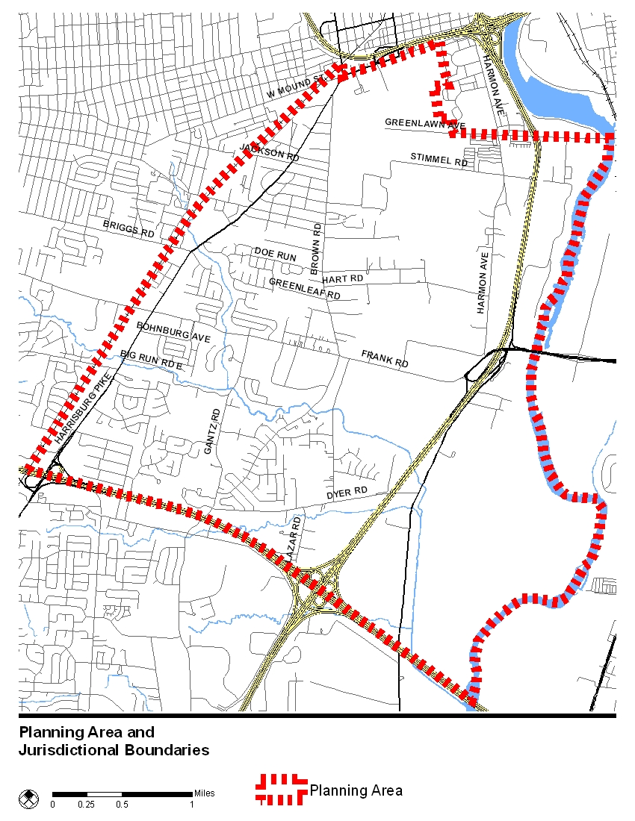

Please list your top 5 issues (positive or negative)
1.
2.
3.
4.
5.

