FY 2023 Comprehensive Performance and Evaluation Report (CAPER)

Community Development Block Grant (CDBG)
HOME Investment Partnerships Program (HOME)
Emergency Solutions Grant (ESG)

Final Version Submitted May 7, 2025

Contents
CR-05 - Goals and Outcomes 2
CR-10 - Racial and Ethnic composition of families assisted 10
CR-15 - Resources and Investments 91.520(a) 11
CR-20 - Affordable Housing 91.520(b) 16
CR-25 - Homeless and Other Special Needs 91.220(d, e); 91.320(d, e); 91.520(c) 18
CR-30 - Public Housing 91.220(h); 91.320(j) 20
CR-35 - Other Actions 91.220(j)-(k); 91.320(i)-(j) 21
CR-40 - Monitoring 91.220 and 91.230 25
CR-45 - CDBG 91.520(c) 27
CR-50 - HOME 24 CFR 91.520(d) 28
CR-58 – Section 3 31

CR-05 - Goals and Outcomes
Progress the jurisdiction has made in carrying out its strategic plan and its action plan. 91.520(a)
This could be an overview that includes major initiatives and highlights that were proposed and executed throughout the program year.

The 2023 Fiscal Year (FY) CAPER is the fourth year CAPER of the 2020-2024 5-Year Consolidated Plan that covers the period of April 1, 2023 through March 31, 2024. This report details the County’s progress in meeting the goals and objectives outlined in the Consolidated Plan and the 2023 Annual Action Plan. The CAPER provides accomplishments for the activities undertaken during the 2023 program year. The accomplishments reported include activities that may have been funded in previous plan years but implemented during the 2023 program year.
Franklin County implemented programs funded from three federal grant programs, the Community Development Block Grant (CDBG), HOME Investment Partnerships Program (HOME), and the Emergency Solutions Grant (ESG). For program year 2023, the focus of activities included those activities undertaken to meet the affordable housing needs for low- and moderate-income persons, public services, and emergency shelter for persons experiencing homelessness. Other planned activities not implemented during the 2023 program year include economic development, homeownership assistance, and fair housing activities. These activities may be undertaken in the future.
CDBG
Affordable Housing
CDBG funds were utilized to complete urgent home repairs for low- and moderate-income homeowners. The repairs increase the habitability of the homes and alleviate unsafe or unsanitary living conditions considered a threat to health, safety, or welfare of the homeowner and household members.
Public Services
A program to provide hearing enhancement services and ramps for persons with disabilities was implemented using CDBG funds.
HOME
The lease up of a completed affordable rental unit development, Homes on the Hill, was completed in 2023. This projected increased access to qualify affordable housing for 3 low- and moderate-income households.
ESG
ESG funds supported the operational costs for emergency shelter facilities to benefit individuals and families that are experiencing homelessness. During program year 2023, a total of 866 individuals, representing 268 households, were reported as beneficiaries of the ESG funded shelter program.
CARES Act Funding
Franklin County received a one-time allocation of CARES Act funding in CDBG-CV fund in the amount of $3,156,117. These funds support programs to assist individuals impacted by the COVID-19 emergency event. From program inception through the 2023 program year, Franklin County has expended a total of $2,168,253.30 in CDBG-CV funds for a variety of programs, including small business funding, eviction prevention, and interpretation services.
CDBG-CV
During program year 2023, CDBG-CV funds were used to provide translation services for non-English speaking, and ESL/EFL community members.

Comparison of the proposed versus actual outcomes for each outcome measure submitted with the consolidated plan and explain, if applicable, why progress was not made toward meeting goals and objectives. 91.520(g)
Categories, priority levels, funding sources and amounts, outcomes/objectives, goal outcome indicators, units of measure, targets, actual outcomes/outputs, and percentage completed for each of the grantee’s program year goals.

Goal | Category | Source / Amount | Indicator | Unit of Measure | Expected – Strategic Plan | Actual – Strategic Plan | Percent Complete | Expected – Program Year | Actual – Program Year | Percent Complete
Ensure Equal Access to Housing | Affordable Housing | CDBG: $100000 | Public service activities other than Low/Moderate Income Housing Benefit | Persons Assisted | 0 | 0 |  | 4000 | 0 | 0.00%
Ensure Equal Access to Housing | Affordable Housing | CDBG: $100000 | Public service activities for Low/Moderate Income Housing Benefit | Households Assisted | 0 | 0 |  | 60 | 0 | 0.00%
Ensure Equal Access to Housing | Affordable Housing | CDBG: $100000 | Homelessness Prevention | Persons Assisted | 0 | 0 |  | 240 | 0 | 0.00%
Ensure Equal Access to Housing | Affordable Housing | CDBG: $100000 | Other | Other | 10000 | 0 | 0.00%
Ensure Safe and Sanitary Property Conditions | Affordable Housing | CDBG: $925000 | Public service activities other than Low/Moderate Income Housing Benefit | Persons Assisted | 0 | 0 |  | 900 | 0 | 0.00%
Ensure Safe and Sanitary Property Conditions | Affordable Housing | CDBG: $925000 | Homeowner Housing Rehabilitated | Household Housing Unit | 4140 | 0 | 0.00% | 120 | 0 | 0.00%
Ensure Safe and Sanitary Property Conditions | Affordable Housing | CDBG: $925000 | Other | Other | 0 | 0 |  | 60 | 0 | 0.00%
Foster Business Expansions in Areas of Need | Non-Housing Community Development |  | Jobs created/retained | Jobs | 100 | 0 | 0.00%
Foster Business Expansions in Areas of Need | Non-Housing Community Development |  | Businesses assisted | Businesses Assisted | 100 | 0 | 0.00%
Foster Development of Skills for Residents in Need | Non-Housing Community Development |  | Public service activities other than Low/Moderate Income Housing Benefit | Persons Assisted | 300 | 0 | 0.00%
Improve Health Outcomes | Non-Homeless Special Needs  Non-Housing Community Development |  | Public service activities other than Low/Moderate Income Housing Benefit | Persons Assisted | 6500 | 0 | 0.00% | 10095 | 0 | 0.00%
Increase Access to Housing and Emergency Shelter | Affordable Housing  Homeless | CDBG: $300000 | Public service activities other than Low/Moderate Income Housing Benefit | Persons Assisted | 1200 | 0 | 0.00%
Increase Access to Housing and Emergency Shelter | Affordable Housing  Homeless | CDBG: $300000 | Homeless Person Overnight Shelter | Persons Assisted | 8000 | 0 | 0.00% | 1020 | 0 | 0.00%
Preserve and Expand Affordable Housing | Affordable Housing | CDBG: $1025000 / HOME: $900000 | Rental units constructed | Household Housing Unit | 400 | 0 | 0.00% | 40 | 0 | 0.00%
Preserve and Expand Affordable Housing | Affordable Housing | CDBG: $1025000 / HOME: $900000 | Homeowner Housing Added | Household Housing Unit | 25 | 0 | 0.00% | 12 | 0 | 0.00%
Preserve and Expand Affordable Housing | Affordable Housing | CDBG: $1025000 / HOME: $900000 | Homeowner Housing Rehabilitated | Household Housing Unit | 370 | 0 | 0.00% | 73 | 0 | 0.00%
Preserve and Expand Affordable Housing | Affordable Housing | CDBG: $1025000 / HOME: $900000 | Direct Financial Assistance to Homebuyers | Households Assisted | 65 | 0 | 0.00% | 17 | 0 | 0.00%
Preserve and Expand Affordable Housing | Affordable Housing | CDBG: $1025000 / HOME: $900000 | Homelessness Prevention | Persons Assisted | 0 | 0 |  | 240 | 0 | 0.00%
Provide Education/Recreational Youth Programs | Non-Housing Community Development |  | Public service activities other than Low/Moderate Income Housing Benefit | Persons Assisted | 3600 | 0 | 0.00%
Provide Homebuyer Education and other Counseling | Affordable Housing | CDBG: $15000 | Public service activities for Low/Moderate Income Housing Benefit | Households Assisted | 0 | 0 |  | 75 | 0 | 0.00%
Provide Housing For Special Needs Populations | Affordable Housing  Homeless  Non-Homeless Special Needs | CDBG: $800000 / HOME: $900000 | Public service activities for Low/Moderate Income Housing Benefit | Households Assisted | 1200 | 0 | 0.00%
Provide Housing For Special Needs Populations | Affordable Housing  Homeless  Non-Homeless Special Needs | CDBG: $800000 / HOME: $900000 | Rental units constructed | Household Housing Unit | 0 | 0 |  | 120 | 0 | 0.00%
Provide Housing For Special Needs Populations | Affordable Housing  Homeless  Non-Homeless Special Needs | CDBG: $800000 / HOME: $900000 | Homeowner Housing Rehabilitated | Household Housing Unit | 0 | 0 |  | 20 | 0 | 0.00%
Provide Housing For Special Needs Populations | Affordable Housing  Homeless  Non-Homeless Special Needs | CDBG: $800000 / HOME: $900000 | Homeless Person Overnight Shelter | Persons Assisted | 8000 | 0 | 0.00%
Public Facilities/Infrastructure Improvements | Non-Housing Community Development | CDBG: $250000 | Public Facility or Infrastructure Activities for Low/Moderate Income Housing Benefit | Households Assisted | 2500 | 0 | 0.00% | 100 | 0 | 0.00%
Table 1 - Accomplishments – Program Year & Strategic Plan to Date

Assess how the jurisdiction’s use of funds, particularly CDBG, addresses the priorities and specific objectives identified in the plan, giving special attention to the highest priority activities identified.
The funds allocated to activities address the highest priority needs for increased access to affordable housing, access to public services, and services for persons experiencing homelessness. Funds were utilized to improve the habitability of homes for low- and moderate income homeowners, provide public services for individuals with hearing impairments and disabilities that impact mobility, and to increase the supply of affordable rental housing.
The County is anticipating redirecting focus during the 2024 program year to meet other priorities identified in the Consolidated Plan and is considering other eligible CDBG public infrastructure improvements.

CR-10 - Racial and Ethnic composition of families assisted
Describe the families assisted (including the racial and ethnic status of families assisted). 91.520(a)

 | CDBG | HOME
White | 143 | 1
Black or African American | 37 | 2
Asian | 1 | 0
American Indian or American Native | 4 | 0
Native Hawaiian or Other Pacific Islander | 0 | 0

Total | 185 | 3

Hispanic | 6 | 0
Not Hispanic | 179 | 3

Describe the clients assisted (including the racial and/or ethnicity of clients assisted with ESG)
 | HESG
American Indian, Alaska Native, or Indigenous | 1
Asian or Asian American | 1
Black, African American, or African | 607
Hispanic/Latina/e/o | 11
Middle Eastern or North African | 0
Native Hawaiian or Pacific Islander | 0
White | 105
Multiracial | 141
Client doesn't know | 0
Client prefers not to answer | 0
Data not collected | 0
Total | 866

Table 2 – Table of assistance to racial and ethnic populations by source of funds

Narrative

CR-15 - Resources and Investments 91.520(a)
Identify the resources made available
Source of Funds | Source | Resources Made Available | Amount Expended During Program Year
CDBG | public - federal | 6,114,353 | 1,529,336
HOME | public - federal | 1,033,738 | 7,908
ESG | public - federal | 180,974 | 0
Table 3 - Resources Made Available

Narrative

Identify the geographic distribution and location of investments
Target Area | Planned Percentage of Allocation | Actual Percentage of Allocation | Narrative Description
Table 4 – Identify the geographic distribution and location of investments

Narrative
During PY 2023, the County expended a total of $1,529,335.56 in CDBG funds on eligible activities as follows:
Hearing Enhancement Services and Ramp Installation- $37,455.75
Urgent Home repair- $1,491,879.81
HOME funds in the amount of $250,000 was utilized to complete the CHDO development of affordable rental housing through the Homes on the Hill project. These funds were drawn in prior year so they are not reflected in the table above. The $7,908.30 drawn during the program year supported the CHDO development and capacity building activity.
ESG funds were not drawn during the fiscal year before the deadline to include in the CAPER report, however the subrecipient of ESG funds provided services and all 2022 ESG funds have been drawn. Activities that took place during the 2023 program year are included in the ESG CAPER report from the SAGE system, and the reimbursable portion of expenditures will be drawn in FY 2024. Program activities supported with ESG funds implemented during program year 2023 include emergency shelter, Homeless Management Information System (HMIS), and Administration expenses.
Leveraging
Explain how federal funds leveraged additional resources (private, state and local funds), including a description of how matching requirements were satisfied, as well as how any publicly owned land or property located within the jurisdiction that were used to address the needs identified in the plan.
During program year 2023, there was no publically owned land used to address the needs of the Consolidated Plan.
Franklin County utilizes a real estate transaction fee to provide a revenue stream for meeting the required 25% match for HOME funds, and the 100% match for ESG funds.
The County also leverages fees generated by real estate transactions to support affordable housing development and allocates $1 per transaction to the Magnet fund, which is then used to provide grants to affordable housing developers
The amount of match is carried forward from prior year, as Franklin County is not providing information on a match contribution during the 2023 federal fiscal year. The amount of match carried forward is sufficient to cover the 25% match requirements. The table below provides the calculation of match carry forward from the 2020 CAPER report through the 2023 CAPER and includes the match liability for each year.

Fiscal Year Summary – HOME Match
1. Excess match from prior Federal fiscal year | 5,009,795
2. Match contributed during current Federal fiscal year | 0
3. Total match available for current Federal fiscal year (Line 1 plus Line 2) | 5,009,795
4. Match liability for current Federal fiscal year | 100,920
5. Excess match carried over to next Federal fiscal year (Line 3 minus Line 4) | 4,908,874
Table 5 – Fiscal Year Summary - HOME Match Report

Match Contribution for the Federal Fiscal Year
Project No. or Other ID | Date of Contribution | Cash  (non-Federal sources) | Foregone Taxes, Fees, Charges | Appraised Land/Real Property | Required Infrastructure | Site Preparation, Construction Materials, Donated labor | Bond Financing | Total Match
N/A | 0 | 0 | 0 | 0 | 0 | 0 | 0 | 0
Table 6 – Match Contribution for the Federal Fiscal Year

HOME MBE/WBE report
Program Income – Enter the program amounts for the reporting period
Balance on hand at begin-ning of reporting period  $ | Amount received during reporting period  $ | Total amount expended during reporting period  $ | Amount expended for TBRA  $ | Balance on hand at end of reporting period  $
37,796 | 109,182 | 0 | 0 | 146,977
Table 7 – Program Income

Minority Business Enterprises and Women Business Enterprises – Indicate the number and dollar value of contracts for HOME projects completed during the reporting period

 | Total | Minority Business Enterprises |  |  |  | White Non-Hispanic
 |  | Alaskan Native or American Indian | Asian or Pacific Islander | Black Non-Hispanic | Hispanic

Contracts
Dollar Amount | 0 | 0 | 0 | 0 | 0 | 0
Number | 0 | 0 | 0 | 0 | 0 | 0

Sub-Contracts
Number | 0 | 0 | 0 | 0 | 0 | 0
Dollar Amount | 0 | 0 | 0 | 0 | 0 | 0

 | Total | Women Business Enterprises | Male

Contracts
Dollar Amount | 0 | 0 | 0
Number | 0 | 0 | 0

Sub-Contracts
Number | 0 | 0 | 0
Dollar Amount | 0 | 0 | 0
Table 8 - Minority Business and Women Business Enterprises

Minority Owners of Rental Property – Indicate the number of HOME assisted rental property owners and the total amount of HOME funds in these rental properties assisted

 | Total | Minority Property Owners |  |  |  | White Non-Hispanic
 |  | Alaskan Native or American Indian | Asian or Pacific Islander | Black Non-Hispanic | Hispanic
Number | 0 | 0 | 0 | 0 | 0 | 0
Dollar Amount | 0 | 0 | 0 | 0 | 0 | 0
Table 9 – Minority Owners of Rental Property

Relocation and Real Property Acquisition – Indicate the number of persons displaced, the cost of relocation payments, the number of parcels acquired, and the cost of acquisition

Parcels Acquired | 0 | 0
Businesses Displaced | 0 | 0
Nonprofit Organizations Displaced | 0 | 0
Households Temporarily Relocated, not Displaced | 0 | 0

Households Displaced | Total | Minority Property Enterprises |  |  |  | White Non-Hispanic
 |  | Alaskan Native or American Indian | Asian or Pacific Islander | Black Non-Hispanic | Hispanic
Number | 0 | 0 | 0 | 0 | 0 | 0
Cost | 0 | 0 | 0 | 0 | 0 | 0
Table 10 – Relocation and Real Property Acquisition

CR-20 - Affordable Housing 91.520(b)
Evaluation of the jurisdiction's progress in providing affordable housing, including the number and types of families served, the number of extremely low-income, low-income, moderate-income, and middle-income persons served.

 | One-Year Goal | Actual
Number of Homeless households to be provided affordable housing units | 3,000 | 0
Number of Non-Homeless households to be provided affordable housing units | 250 | 174
Number of Special-Needs households to be provided affordable housing units | 80 | 0
Total | 3,330 | 174
Table 11 – Number of Households

 | One-Year Goal | Actual
Number of households supported through Rental Assistance | 3,000 | 0
Number of households supported through The Production of New Units | 210 | 3
Number of households supported through Rehab of Existing Units | 40 | 171
Number of households supported through Acquisition of Existing Units | 0 | 0
Total | 3,250 | 174
Table 12 – Number of Households Supported

Discuss the difference between goals and outcomes and problems encountered in meeting these goals.
The difference between goals and outcomes can be attributed to staff turnover and the training of new program staff on the various program policies and requirements to implement programs. To facilitate moving projects forward, program staff are working with consultants and County departments to assist with identifying CDBG eligible activities that can be efficiently implemented to facilitate meeting the projects outcomes of the plan.
Discuss how these outcomes will impact future annual action plans.
The difficulties encountered in meeting the goals of the Consolidated Plan are expected to result in a reallocation of funding to public infrastructure projects, which can be expected to benefit a larger portion of the low-and moderate-income population. The funding decisions continue to align with the current consolidated plan.
Include the number of extremely low-income, low-income, and moderate-income persons served by each activity where information on income by family size is required to determine the eligibility of the activity.

Number of Households Served | CDBG Actual | HOME Actual
Extremely Low-income | 34 | 1
Low-income | 61 | 2
Moderate-income | 76 | 0
Total | 171 | 3
Table 13 – Number of Households Served

Narrative Information
The beneficiaries of the urgent home repair program are reported for the CDBG program, and of the total 171 persons served, 50.3% of those served were moderate-income households whose total household income was between 51% and 80% of the Area Median Income (AMI), 40.4% were low-income households whose income was between 31% AMI and 50% AMI, and 22.5% were extremely low-income households whose income did not exceed 30% AMI. The HOME assisted units leased during the program year served a total of 3 households, of which 1 household was extremely low-income, and 2 households were low-income.

CR-25 - Homeless and Other Special Needs 91.220(d, e); 91.320(d, e); 91.520(c)
Evaluate the jurisdiction’s progress in meeting its specific objectives for reducing and ending homelessness through:
Reaching out to homeless persons (especially unsheltered persons) and assessing their individual needs
Within Franklin County, the Community Shelter Board (CSB) is the designated lead agency for the Continuum of Care (CoC) and is responsible for managing the Homeless Management Information System (HMIS) and the coordinated entry system. The partner homeless services providers utilize the CSB assessment tool to refer persons and families experiencing homelessness to emergency shelter (ES), rapid re-housing (RRH), and Permanent Supportive Housing (PSH). The street outreach programs operated by the CoC partner agencies are considered the access point for the coordinated entry system, and outreach teams assist persons experiencing homelessness to access the essential services needed to access housing. The CSB also conducts the annual Point in Time (PIT) count and has developed on-going working groups to analyze the PIT data for strategy development.
Addressing the emergency shelter and transitional housing needs of homeless persons
Franklin County uses a coordinated point of access to quickly assess and engage people at-risk of or experiencing homelessness. When possible, the family or individual is diverted from entering the homelessness services system and to prevent the loss of housing. If a family or individual cannot be diverted, emergency shelter and crisis services are provided while permanent stable housing and appropriate supports are being secured. Households entering emergency shelter are connected to programs that provide housing assistance and services utilizing the “housing first” model.
Helping low-income individuals and families avoid becoming homeless, especially extremely low-income individuals and families and those who are: likely to become homeless after being discharged from publicly funded institutions and systems of care (such as health care facilities, mental health facilities, foster care and other youth facilities, and corrections programs and institutions); and, receiving assistance from public or private agencies that address housing, health, social services, employment, education, or youth needs
The coordinated point of access has the primary role of assessing individuals and families that are in a housing crisis including those discharged from publicly funded institutions and systems of care. The assessment establishes the nature of the housing crisis. If the housing crisis can be easily averted, local resources are used for community based assistance. If community based assistance is not the appropriate intervention, the coordinated point of access assesses eligibility, in the case of families, for a homelessness prevention program. If all these resources are exhausted and the family cannot be helped without homeless system resources, the individual or family is referred to the most appropriate emergency shelter.
Helping homeless persons (especially chronically homeless individuals and families, families with children, veterans and their families, and unaccompanied youth) make the transition to permanent housing and independent living, including shortening the period of time that individuals and families experience homelessness, facilitating access for homeless individuals and families to affordable housing units, and preventing individuals and families who were recently homeless from becoming homeless again
Franklin County utilizes the “housing first” model, a philosophy stating that most households housed in permanent housing quickly and with support, can maintain stability. The focus is on each household obtaining permanent housing. Rapid rehousing and permanent supportive housing resources are available to individuals and families based on their needs. These programs prioritize housing for the most vulnerable residents. Aftercare services are provided to help households maintain their new housing. Households are encouraged to contact their former case manager to avoid a shelter reentry, if possible, if they have a housing crisis. The goal is to reduce recidivism into shelter. If permanent supportive housing is the right intervention, supportive services are provided to the household, as desired.

CR-30 - Public Housing 91.220(h); 91.320(j)
Actions taken to address the needs of public housing
The Columbus Metropolitan Housing Authority (CMHA), a separate governmental entity, administers public housing new construction, rehabilitation and modernization activities, home ownership opportunity programs and the Housing Choice Voucher Program for its tenant population. CMHA is the primary provider of affordable housing for extremely low-income families, elderly and the disabled in Columbus. CMHA's affordable housing objectives are achieved through development and management of public housing units and Housing Choice Vouchers (HCV). Through a contract with HUD, CMHA has 1,530 public housing units and 7,965 HCVs. CMHA coordinated with Franklin County and the City of Columbus to create a Five-Year Demolition/Disposition plan. CMHA conducted an analysis of its public housing portfolio and determined which projects were physically sound, financially solvent and met current HUD standards for site selection and development.
Actions taken to encourage public housing residents to become more involved in management and participate in homeownership
Franklin County and the City of Columbus coordinate with the Community Relations Commission to meet and exchange information with tenants of public housing projects to discuss issues of concern and devise constructive solutions. The County works with the Tenant Outreach Coordinator from the Coalition on Homelessness and Housing in Ohio to assist in these endeavors.
Actions taken to provide assistance to troubled PHAs
CMHA is not designated as a troubled PHA by HUD.

CR-35 - Other Actions 91.220(j)-(k); 91.320(i)-(j)
Actions taken to remove or ameliorate the negative effects of public policies that serve as barriers to affordable housing such as land use controls, tax policies affecting land, zoning ordinances, building codes, fees and charges, growth limitations, and policies affecting the return on residential investment. 91.220 (j); 91.320 (i)
Franklin County is in the process of updating zoning code (for any townships that have not adopted their own code) and is evaluating its residential permitting process to reduce barriers to affordable housing development. In accordance with state law, Franklin County does not have the authority to change building code or tax policies. The County is not able to change zoning codes or fees within any incorporated areas of the jurisdiction, or in townships that have elected to adopt their own zoning since Ohio is a home rule state.
Actions taken to address obstacles to meeting underserved needs. 91.220(k); 91.320(j)
In the Strategic Plan the county identified "affordable housing preservation and development" and "the provision of safe and sanitary housing" as priority needs. The County has several programs in place that address these obstacles. Developers, using low-income housing tax credits, receive guidance and support through existing or new project-based support. In combination, or separately, these projects serve seniors, the homeless, provide service enriched rental housing, and utilize land from the Franklin County Land Bank. Additionally, the County will be funding an affordable housing strategy in 2021 funded with general fund allocations and has adopted a poverty reduction plan.
For those individuals most in need, the county provides programs for owner-occupied housing rehabilitation, emergency repair, rental rehabilitation, and critical repairs for seniors living in their homes. By using federal funds and local bond dollars, the county funds vacancy prevention programs in neighborhoods with the highest vacancy rates. These programs provide the necessary assistance to allow homeowners to remain in a safe and sanitary home and prevent further vacant housing. For greater impact, the county bond programs are not income restricted. When combined with the federal income restricted programs, this allows the county to impact the quality of life for an increased number of residents.
A key underserved group in Franklin County are individuals with special needs, particularly those living with a disability. Low funding levels are consistently cited as the reason for the shortage of services. The County attempts to secure additional funds through its housing rehab programs that place a no interest loan on home that is not payable until the homeowner sales of vacates their property. Further, all County rental programs require tenants to be at or below 80% AMI. County homebuyer programs continue outreach with lenders including on-site training and outreach at homebuyer education classes (Including pre and post counseling).
Actions taken to reduce lead-based paint hazards. 91.220(k); 91.320(j)
The Franklin County Public Health office provides information on and testing for lead-based paint in pre-1978 homes. Households that are income eligible can receive assistance to mitigate the lead-based paint to improve health outcomes for the family, through the Urgent Repair program, implemented by the Mid-Ohio Regional Planning Commission (MORPC) and its Urgent Need repair program administered by the Board of Health. The MORPC program provides substantive repairs to homes, while the Board of Health program addresses single repair items such as furnaces which present a safety occupation issue. Additionally, the County has implemented EPA standards for lead-based paint identification and abatement.
These actions apply to properties built before 1978 and in work areas where painted surfaces will be disturbed. Lead hazard control, lead education, outreach and research are the focus of the program. All County funded rehabilitation projects must pass a lead assessment.
Actions taken to reduce the number of poverty-level families. 91.220(k); 91.320(j)
The County adopted a strategy to reduce poverty and improve economic mobility through its Poverty Reduction Blueprint, adopted in 2019.
The County is working to employ the following goals and strategies:
• Initiating workforce development programs coordinating businesses with local curriculums.
• Creating jobs and through local incentives
• Provide sufficient housing which working families can afford.
Programs funded with CDBG and HOME funds provide homeowner and rental rehabilitation and repairs, new construction of rental and homeowner units and downpayment assistance for income-eligible, first-time homebuyers. These activities, which produce and preserve affordable housing, are important in reducing the number of poverty-level families in the county. Using CDBG funding, county programs also support activities that provide childcare and recreational activities, health care programs that provide education and training for low income individuals, and economic development programs that require the creation of jobs. Using general fund dollars, the county provides funding for anti-poverty activities such as literacy and job training.
The county implements the federally required Section 3 program which is intended to ensure that when employment or contracting opportunities are generated by HUD funded Section 3 covered projects, preference is given to qualified low and very low income persons or business concerns.
Further, the County’s anti-poverty strategy focuses on the concept of coordination and linkages. The goals and objectives in the strategic plan describe the roles that the county will play in regional efforts to move people out of poverty and to revitalize areas of the community with high poverty levels. Key strategies include:
• Focusing resources on populations and areas with the greatest need in coordination with where the greatest chances of success are possible.
• Coordinating physical development with provision of supportive services for persons with special needs.
• Enabling low-income persons to accumulate assets through homeownership and business development.
• Providing access for people in poverty to employment opportunities.
• Empowering low-income residents to provide leadership and solve problems in their neighborhoods.
The county's economic development strategy emphasizes job creation, retention of existing jobs and targeted commercial revitalization. The county contracted with three non-profit organizations, Columbus Community Development Corporation, the Economic and Community Development Institute and the Columbus Urban League to provide working capital, business development, and micro-enterprise loans to existing and start-up businesses.
Actions taken to develop institutional structure. 91.220(k); 91.320(j)
The County supports/participates in the following efforts:
• In the homeowner repair programs, private contractors are utilized to do the designated remodeling of homes.
• If a homeowner applicant is not current on their mortgage or taxes, they are referred to a homeowner counseling agency to determine if a modification of the mortgage is in order.
• Homeowners can work with the County Auditor’s office to set up a payment plan to get current on taxes.
• In the housing programs, the county relies on development organizations to own the properties being redeveloped, secure private contractors to do the construction work and, for homeownership development, utilize private realtors to market property for sale. Homebuyers are required to complete 8 hours of face to face homebuyer counseling through an approved agency prior to home purchase.
• The County provides operating support to Community Housing Development Organizations (CHDOs), through the Community Development (CD) Collaborative of Greater Columbus, to encourage sustained capacity of local CHDOs. The CD Collaborative of Greater Columbus is a non-profit organization that pools resources to provide operating grants and technical assistance to build the capacity of community based non-profit housing developers. The CD Collaborative Board is comprised of various lending institutions including United Way of Central Ohio, The Columbus Foundation, Enterprise Community Partners, and the City of Columbus and Franklin County. Staff for the Collaborative is provided through a contractual relationship with the Affordable Housing Trust for Columbus and Franklin County.
• The Community Development Division of EDP partners with local agencies and contractors to deliver services to the community in the areas of new rental housing, homeownership, owner-occupied housing rehabilitation, rental rehabilitation, construction of affordable homes and homebuyer education. In addition, the county contracts with agencies that provide handyman services to the elderly and disabled as well as the Columbus Urban League to provide fair housing services to county residents. The division supports the work of the Community Shelter Board (CSB) to meet the needs of vulnerable populations. Through the Emergency Solutions Grant, as well as other public and private resources, the CSB continues to coordinate emergency shelter activities that operate emergency homeless shelters in the city.
For efforts around ending Homelessness, Franklin County and the City of Columbus work with CSB to marshal resources and direct funding decisions. The county contracts with the Columbus Urban League to conduct its Fair Housing compliance program. The Community Shelter Board Rebuilding Lives Funder Collaborative (RLFC) consists of local public and private entities that review and provide guidance for funding capital services and operations of permanent supportive housing projects. The County working with and through the Community Shelter Board and the local Continuum of Care, is implementing the redesign of the single adult system. This new design provides coordination among the major single adult emergency shelter providers. A major portion of this re-design is now in place and uses a case management system (Navigators) to help move men and women from shelter to housing more efficiently.
Actions taken to enhance coordination between public and private housing and social service agencies. 91.220(k); 91.320(j)
There are a number of ongoing collaborative efforts in the community. Guided by the Community Shelter Board, the county, city and other entities participate in efforts to address and end homelessness through the Rebuilding Lives initiative. The Community Development Collaborative is funded by the county, city and other private organizations to provide operating support and technical assistance to Community Development Corporations. The Columbus Affordable Housing Task Force which consists of HUD, state and local government staff and development organizations meets every other month to discuss affordable rental projects and preservation opportunities. There is an ongoing collaboration with the Columbus Metropolitan Housing Authority regarding development opportunities, use of project based vouchers and other related issues.
Identify actions taken to overcome the effects of any impediments identified in the jurisdictions analysis of impediments to fair housing choice. 91.520(a)
The County continues to work with housing providers to develop quality housing in all areas of the county. Funds were provided for administrative costs to the Columbus Urban League (CUL) to enable them to provide fair housing services to the residents of the county. These services include increasing the awareness of fair housing issues, fair housing barrier elimination, housing discrimination redress and implementation of the Fair Housing Action Plan. The CUL provides fair housing education and training, investigates all alleged housing discrimination complaints, coordinates and conducts housing discrimination testing sets and affirmative marketing monitoring visits on HOME projects, conducts homebuyer and homeownership education classes and advertising promotions/campaigns in order to reach protected groups.

CR-40 - Monitoring 91.220 and 91.230
Describe the standards and procedures used to monitor activities carried out in furtherance of the plan and used to ensure long-term compliance with requirements of the programs involved, including minority business outreach and the comprehensive planning requirements

Franklin County is in the process of reviewing and updating policies and procedures used in the administration of the HUD entitlement funds. Included in this policy review is the development of a monitoring plan, with a relevant risk assessment to be used to determine the frequency and nature of monitoring for all CDBG, HOME, and ESG funding. Through a combination of remote review of documents and on-site review for activities implemented through subrecipients, the County will conduct monitoring on an annual basis, or more frequently based upon the results of the annual risk assessment to be conducted. County staff will utilize the guidelines provided in the HUD Monitoring Handbook, found at: https://www.hud.gov/program_offices/administration/hudclips/handbooks/cpd/6509.2 to ensure that activities are implemented within the programmatic requirements for each program.
As newly trained staff increase their knowledge and skills in these HUD entitlement programs, internal monitoring processes will be adjusted as needed. During the 2023 Program Year, the County did not undertake any on-site monitoring, and conducted remote monitoring as needed. Monitoring activities will commence during the 2024 Program Year.
Franklin County conducts minority business outreach through its office of Diversity Equity and Inclusion. The County handles the planning requirements through the department of Economic Development and Planning.

Citizen Participation Plan 91.105(d); 91.115(d)
Describe the efforts to provide citizens with reasonable notice and an opportunity to comment on performance reports.
The County provided notice to residents of the availability of the CAPER for review on October 11, 2024, for a 15-day public comment period through October 28, 2024 by publishing an advertisement in a newspaper of general circulation. A copy of the draft CAPER was placed on the County website. A public hearing was held on October 16, 2024 to solicit comments from the public on the draft CAPER prior to submission to HUD. A second public comment period on the draft CAPER was held from February 12 through February 26, 2025 with readvertisement published on January 28, 2025. There were no views or comments received at the public hearing or thorughout each of the public comment periods. A copy of the public notifications is included as an attachment to this document.

CR-45 - CDBG 91.520(c)
Specify the nature of, and reasons for, any changes in the jurisdiction’s program objectives and indications of how the jurisdiction would change its programs as a result of its experiences.
Franklin County does not plan to change any of the program objectives outlined in the strategic plan. While implementation of activities has been delayed due to staff turnover for key roles, the priority needs identified in the 2020-2024 Consolidated Plan remain the same and will be addressed with current and future funds.
Does this Jurisdiction have any open Brownfields Economic Development Initiative (BEDI) grants?
No
[BEDI grantees] Describe accomplishments and program outcomes during the last year.

CR-50 - HOME 24 CFR 91.520(d)
Include the results of on-site inspections of affordable rental housing assisted under the program to determine compliance with housing codes and other applicable regulations
Please list those projects that should have been inspected on-site this program year based upon the schedule in 24 CFR §92.504(d). Indicate which of these were inspected and a summary of issues that were detected during the inspection. For those that were not inspected, please indicate the reason and how you will remedy the situation.
Franklin County did not conduct any physical inspections of HOME assisted units during the 2023 program year. The County staff is in the process of developing policies and procedures for conducting the inspections, as well as a compliance review of the continued affordability conditions. Due to staff turnover within the County, the inspections did not occur during the 2023 or 2024 program years. The attached list of units are due for inspection by March 31, 2026. The County will complete on-site rental inspections of all properties listed in the attached list of units in the 2025 program year, before March 31, 2026. In the past, the County has partnered with the Columbus Metropolitan Housing Authority (CMHA) to conduct these on-site inspectsions, and County staff are planning to partner with CMHA to complete these inspections in subsequent years.
In conjunction with hired consultants, the County is developing a monitoring strategy and monitoring tools that will ensure unit inspections were completed according to the appropriate schedule. The county will review inspection requirements outlined in applicable subrecipients' policies and procedures. The county's staff monitoring tools will include fields to complete with dates of inspections at each stage of the project when performing a monitoring visit. This will include an initial inspection, each payment request inspection, final inspection upon completion, and inspections post completion during the affordability period.
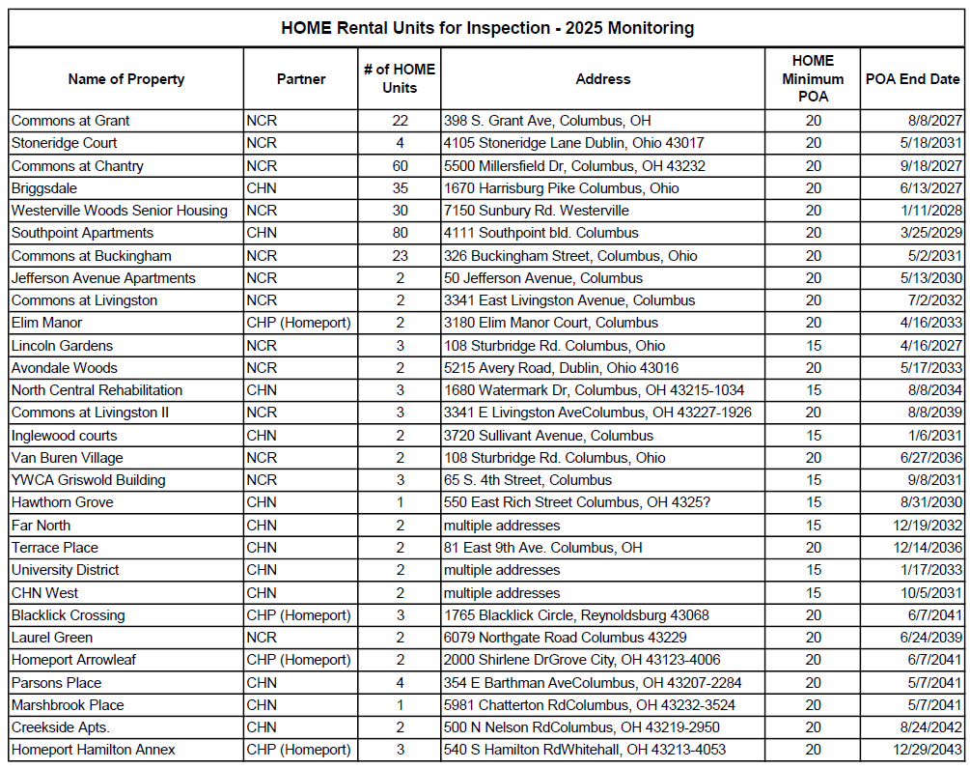
HOME Monitoring Unit List 2025
Provide an assessment of the jurisdiction's affirmative marketing actions for HOME units. 24 CFR 91.520(e) and 24 CFR 92.351(a)
Each HOME funded program has an affirmative marketing plan. As part of the county’s fair housing contract with the Columbus Urban League, sites for rental and homeownership development are monitored to determine that appropriate actions are being taken to assure that projects are in compliance with Fair Housing regulations.
Refer to IDIS reports to describe the amount and use of program income for projects, including the number of projects and owner and tenant characteristics
Franklin County did not expend any HOME program income on activities during the 2023 program year.
Describe other actions taken to foster and maintain affordable housing. 24 CFR 91.220(k) (STATES ONLY: Including the coordination of LIHTC with the development of affordable housing). 24 CFR 91.320(j)
Franklin County continues the work of the Magnet Fund program and Affordable Housing Trust to support the development of affordable housing. The Affordable Housing Trust (AHT) is an independent, nonprofit lender that works with the private, nonprofit, and public sectors to bring affordable housing opportunities to Franklin County and the City of Columbus. As a Certified Community Development Financial Institution (CDFI) the AHT provides an essential financing mechanism that increases the supply of affordable housing units for low- and moderate-income individuals and families. Through its partnership with Franklin County, AHT continues to leverage funding to address the affordable housing needs of the community.

CR-58 – Section 3
Identify the number of individuals assisted and the types of assistance provided

Total Labor Hours | CDBG | HOME | ESG | HOPWA | HTF
Total Number of Activities | 0 | 0 | 0 | 0 | 0
Total Labor Hours
Total Section 3 Worker Hours
Total Targeted Section 3 Worker Hours
Table 15 – Total Labor Hours

Qualitative Efforts - Number of Activities by Program | CDBG | HOME | ESG | HOPWA | HTF
Outreach efforts to generate job applicants who are Public Housing Targeted Workers
Outreach efforts to generate job applicants who are Other Funding Targeted Workers.
Direct, on-the job training (including apprenticeships).
Indirect training such as arranging for, contracting for, or paying tuition for, off-site training.
Technical assistance to help Section 3 workers compete for jobs (e.g., resume assistance, coaching).
Outreach efforts to identify and secure bids from Section 3 business concerns.
Technical assistance to help Section 3 business concerns understand and bid on contracts.
Division of contracts into smaller jobs to facilitate participation by Section 3 business concerns.
Provided or connected residents with assistance in seeking employment including: drafting resumes,preparing for interviews, finding job opportunities, connecting residents to job placement services.
Held one or more job fairs.
Provided or connected residents with supportive services that can provide direct services or referrals.
Provided or connected residents with supportive services that provide one or more of the following: work readiness health screenings, interview clothing, uniforms, test fees, transportation.
Assisted residents with finding child care.
Assisted residents to apply for, or attend community college or a four year educational institution.
Assisted residents to apply for, or attend vocational/technical training.
Assisted residents to obtain financial literacy training and/or coaching.
Bonding assistance, guaranties, or other efforts to support viable bids from Section 3 business concerns.
Provided or connected residents with training on computer use or online technologies.
Promoting the use of a business registry designed to create opportunities for disadvantaged and small businesses.
Outreach, engagement, or referrals with the state one-stop system, as designed in Section 121(e)(2) of the Workforce Innovation and Opportunity Act.
Other.
Table 16 – Qualitative Efforts - Number of Activities by Program

Narrative
There were no activities implemented during program year 2023 subject to the Section 3 requirements

Attachment
2023 CAPER Citizen Participation
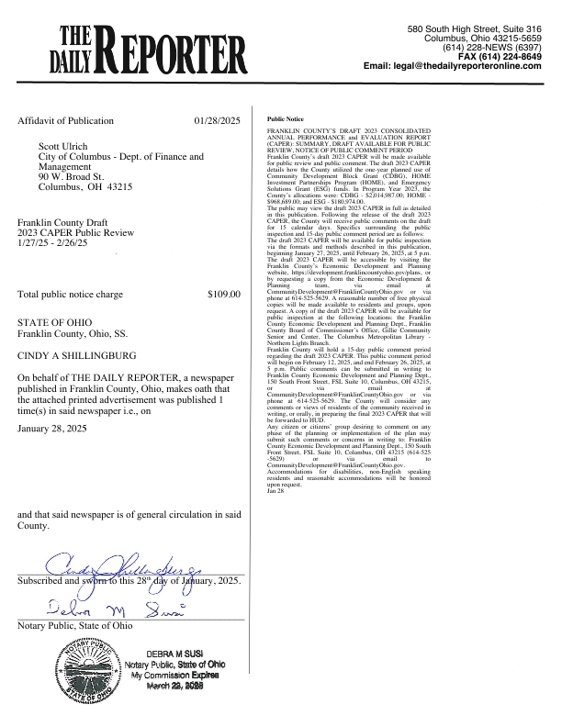
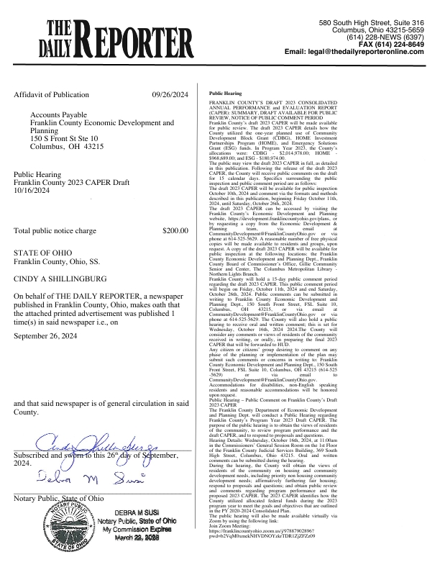
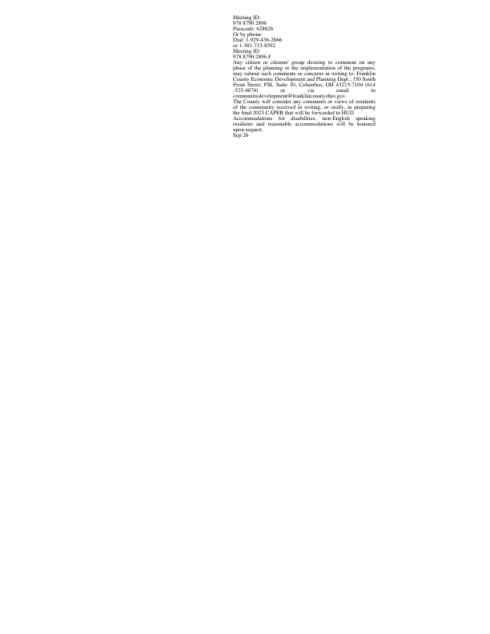
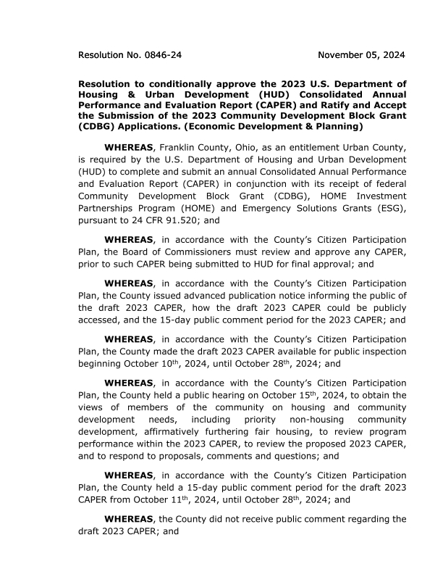
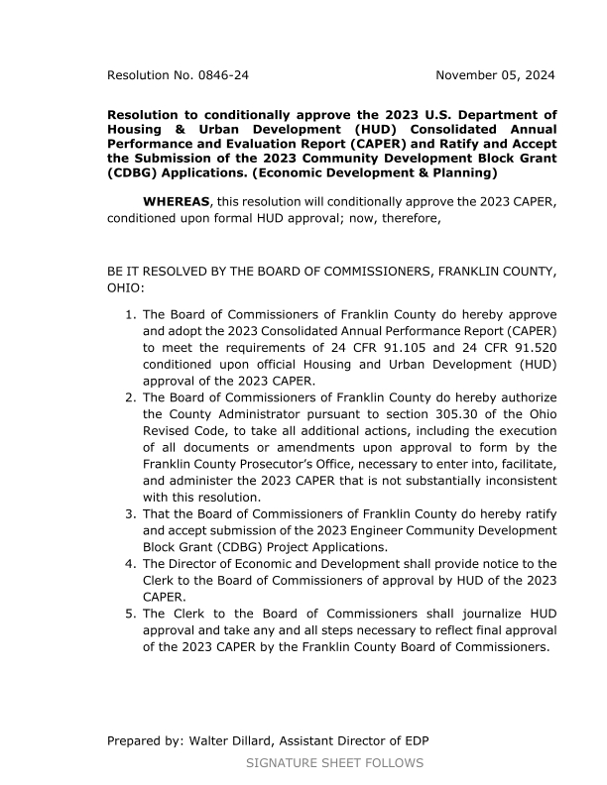
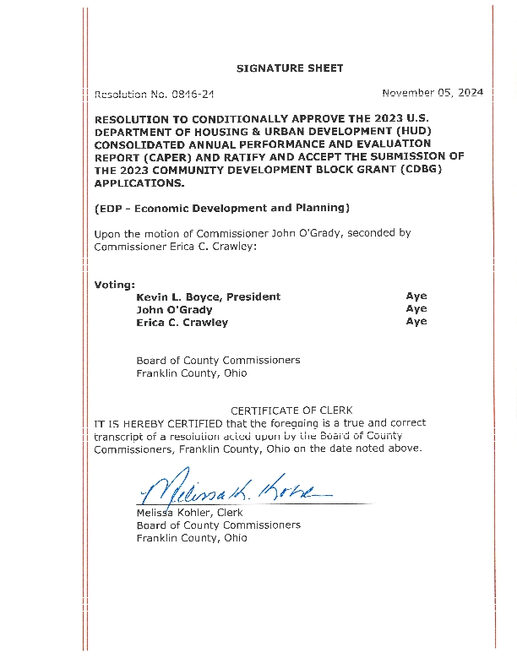
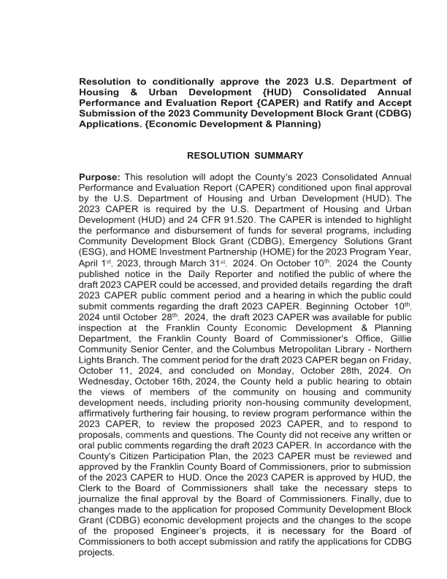


PR26 CDBG and CDBG CV
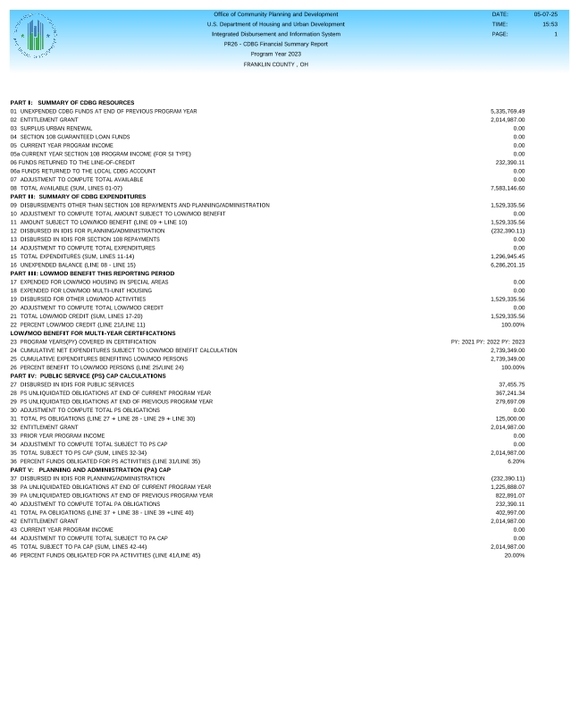
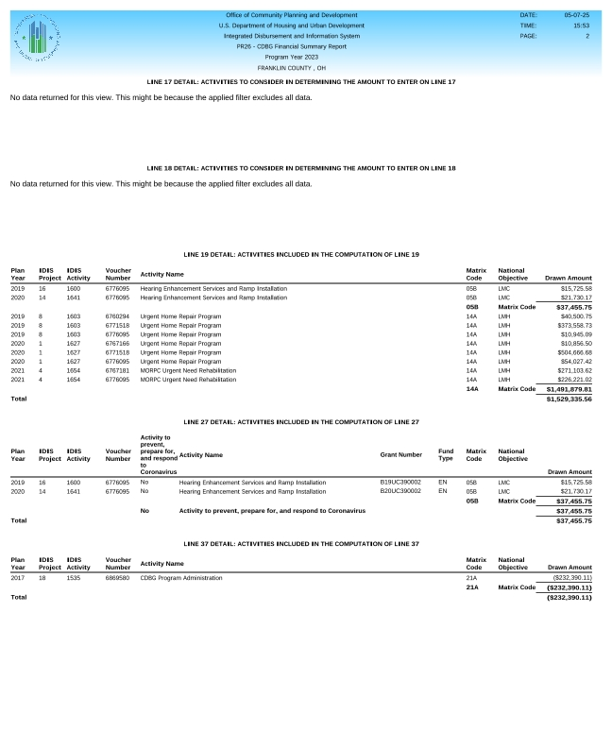
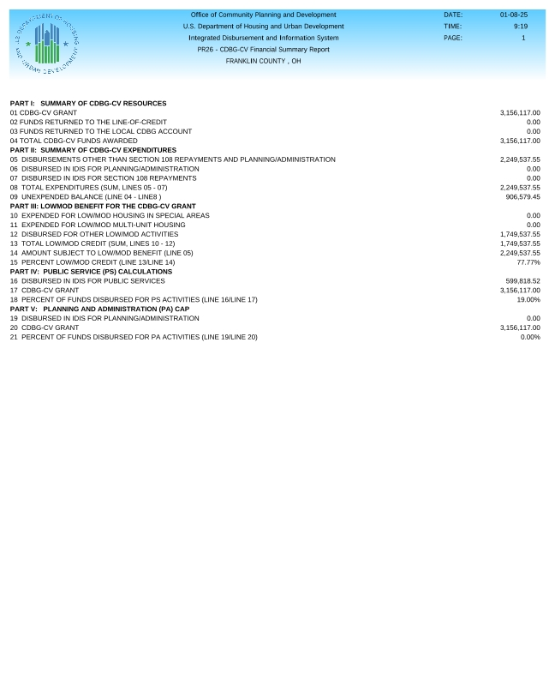
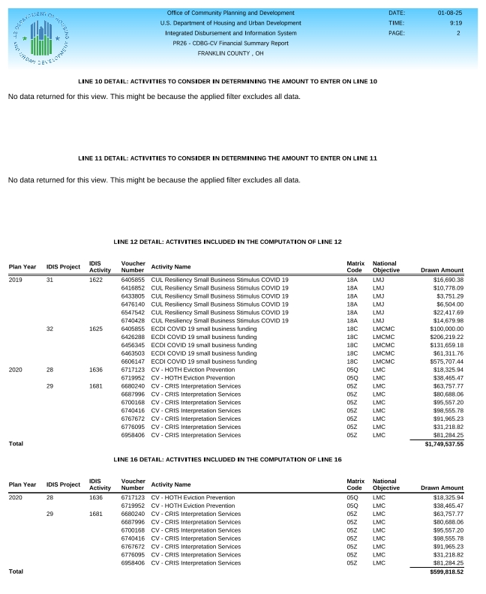
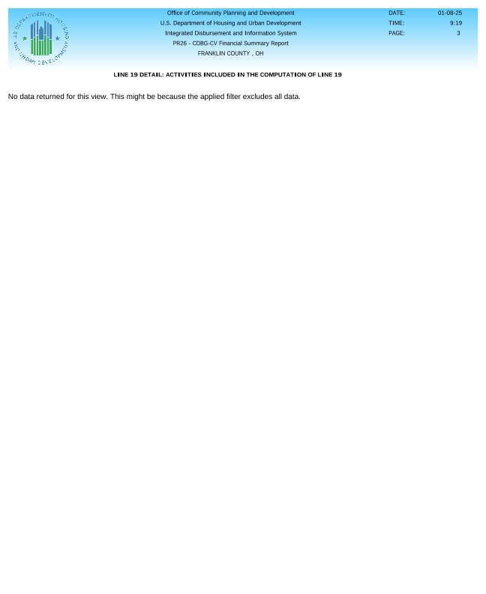

CDBG PR 03 Activity Summary
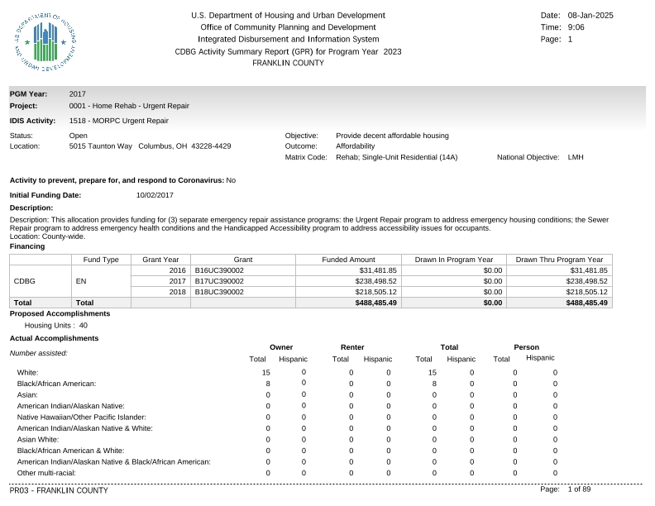
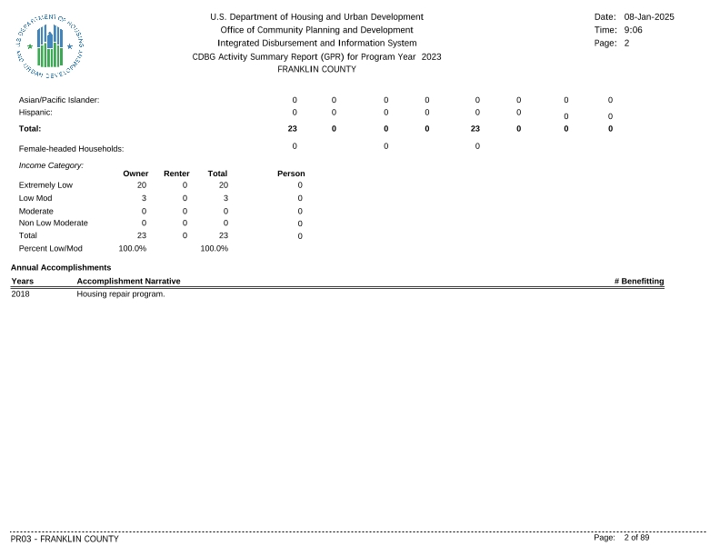
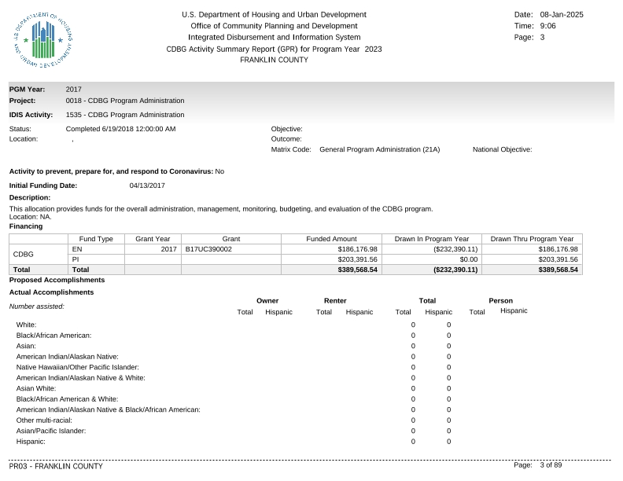
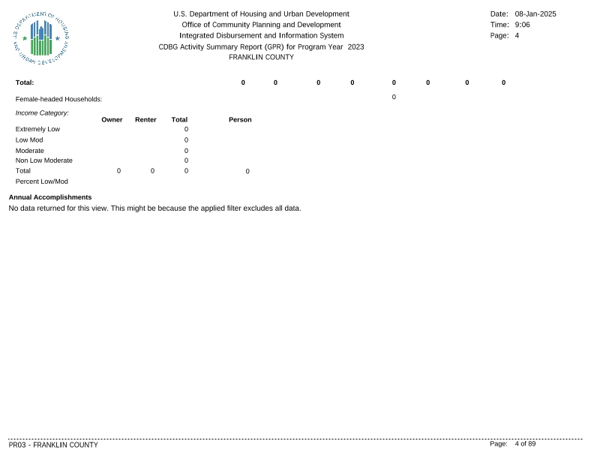
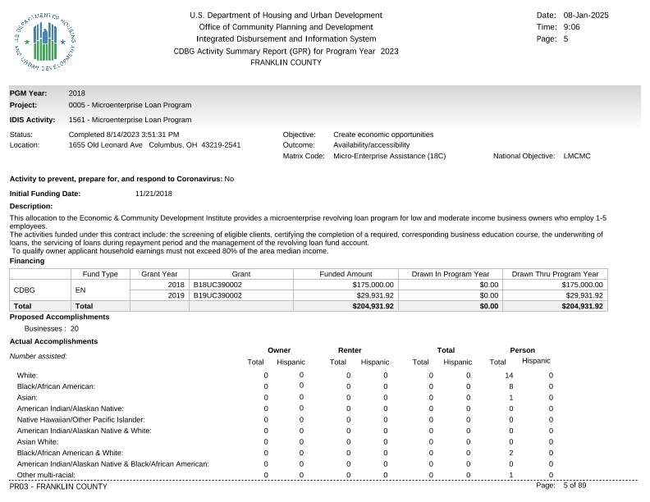
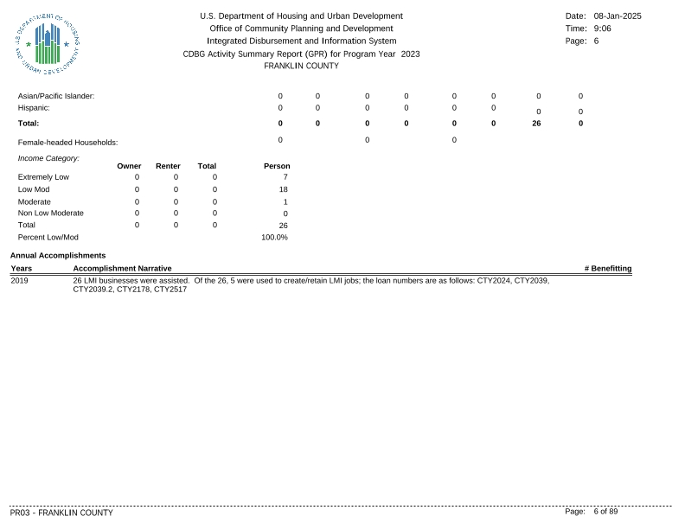
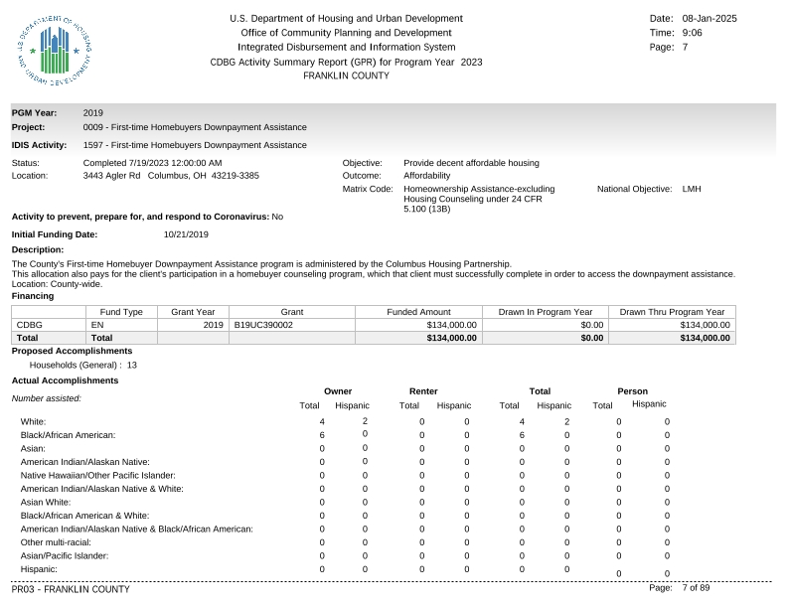
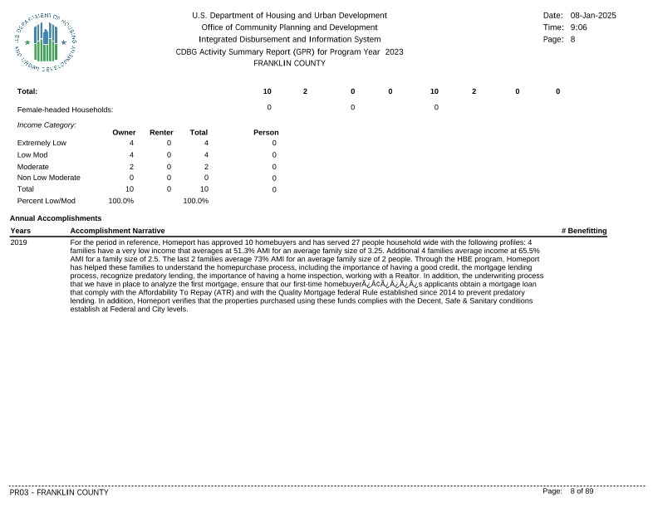
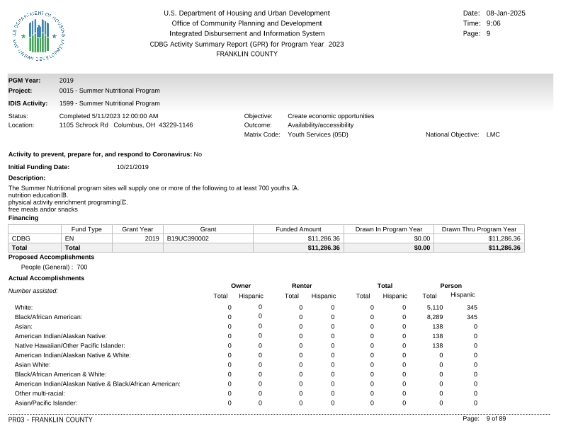
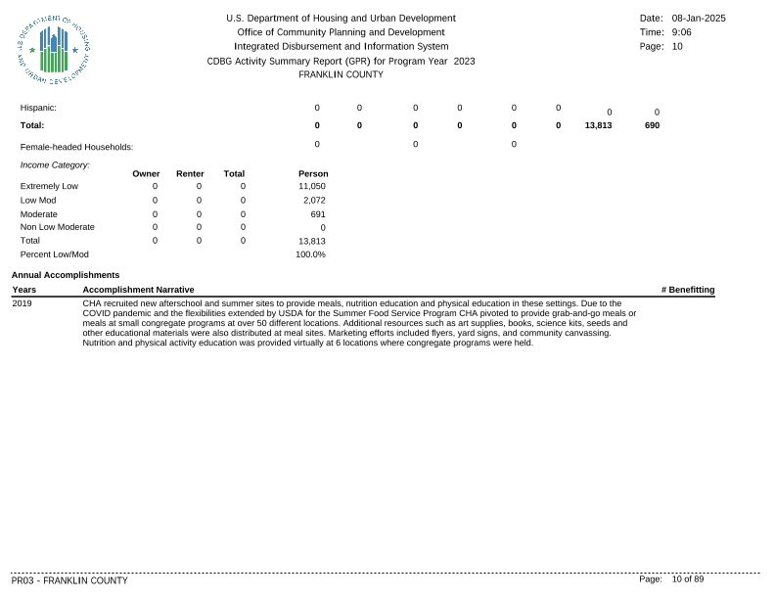
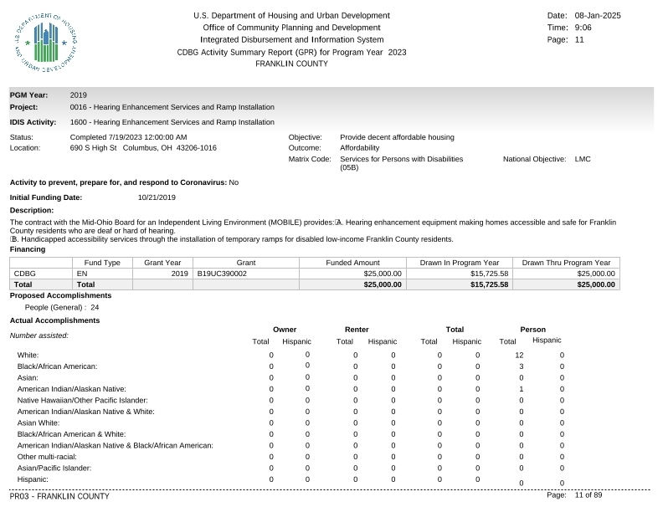
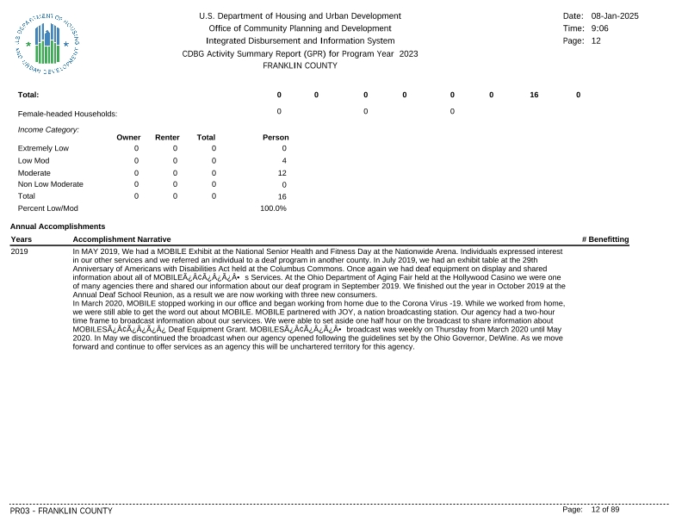
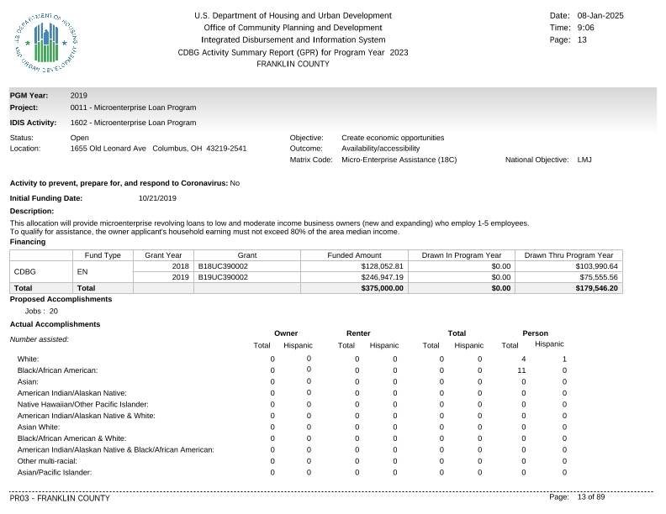
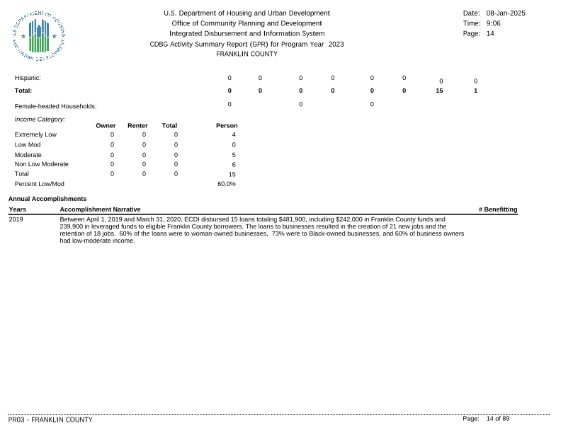
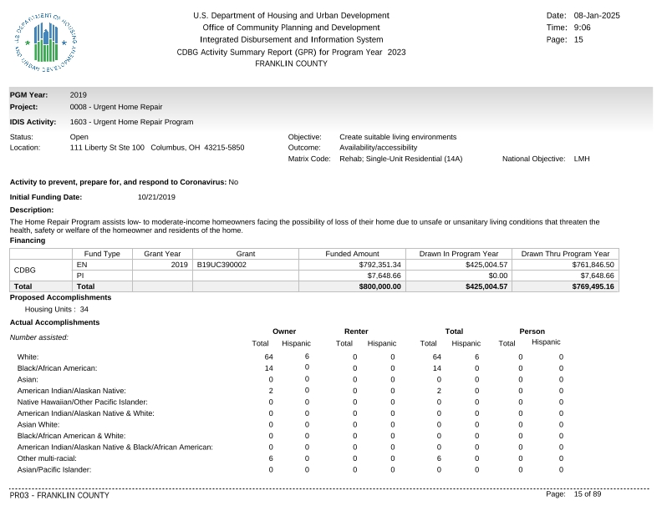
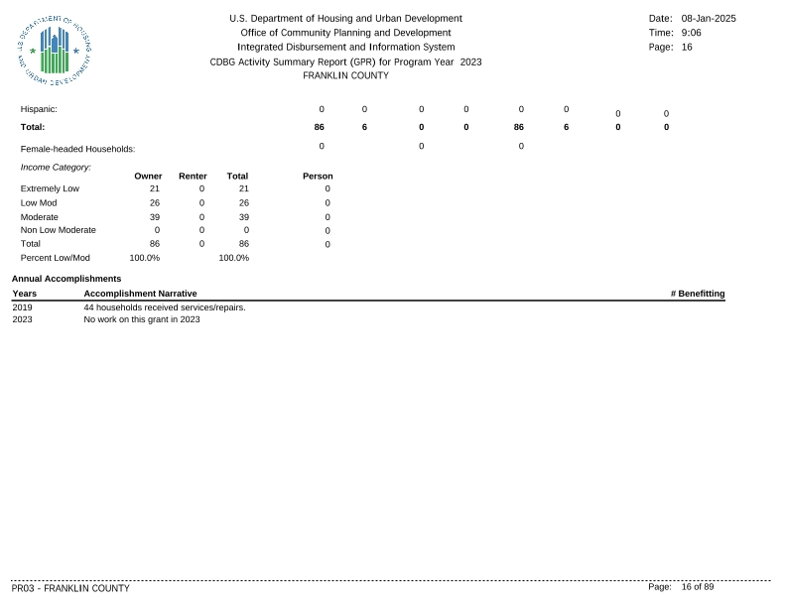
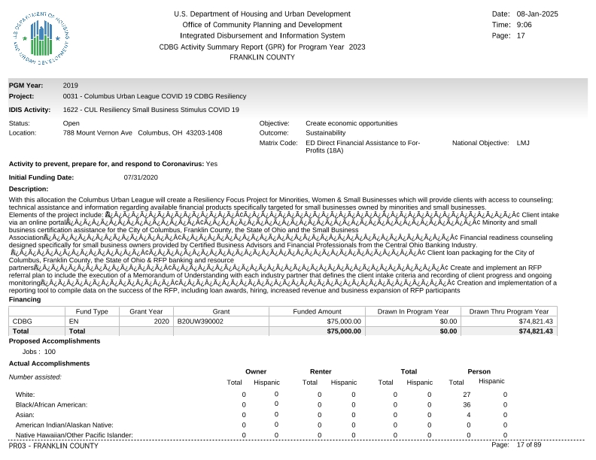
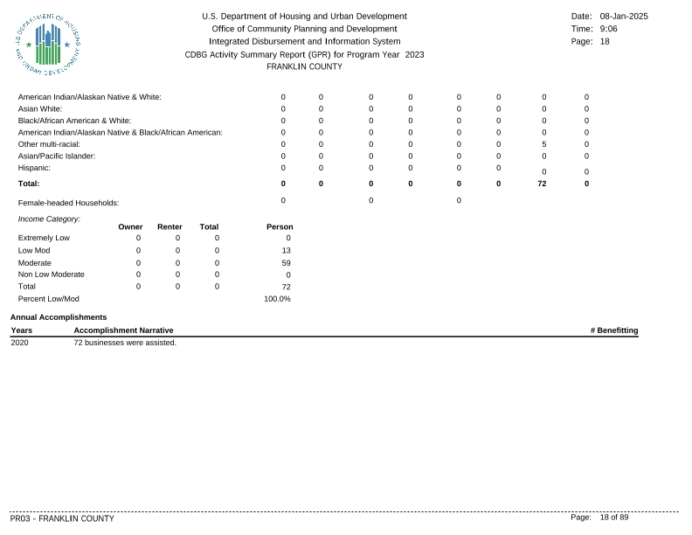
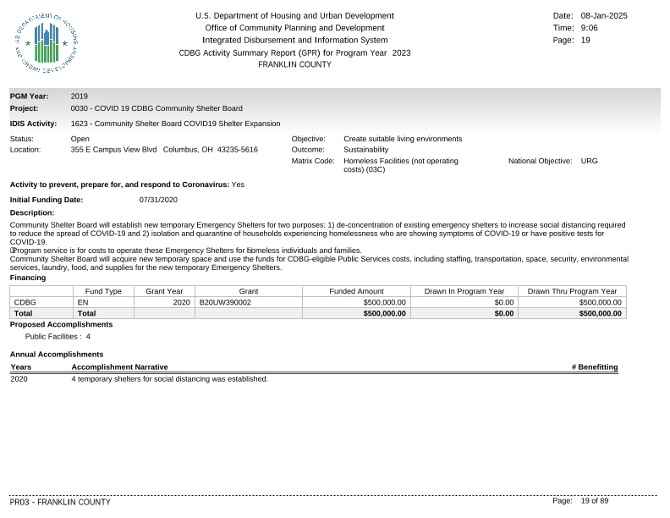
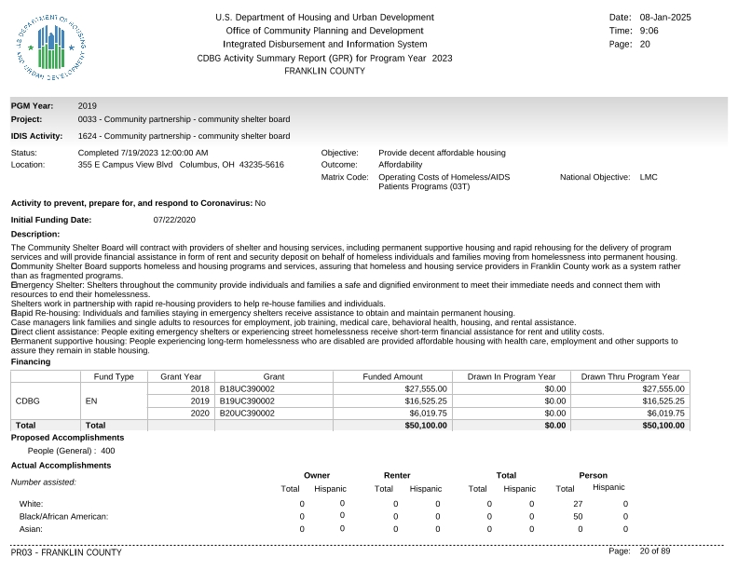
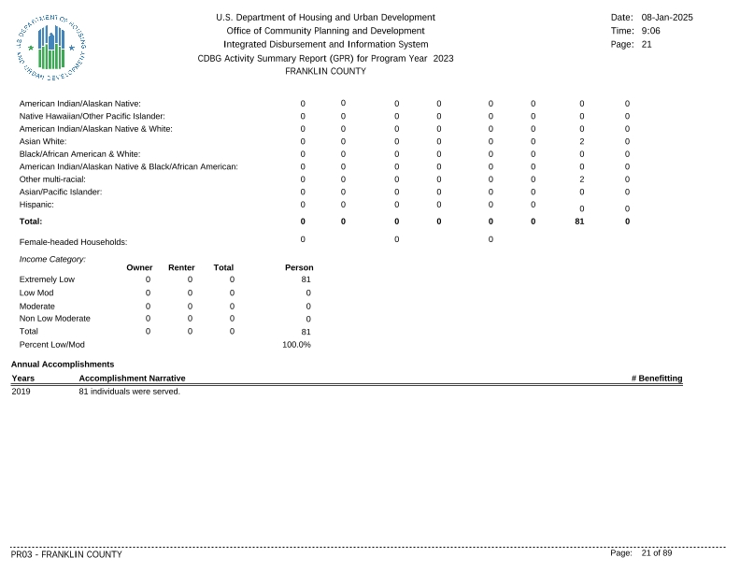
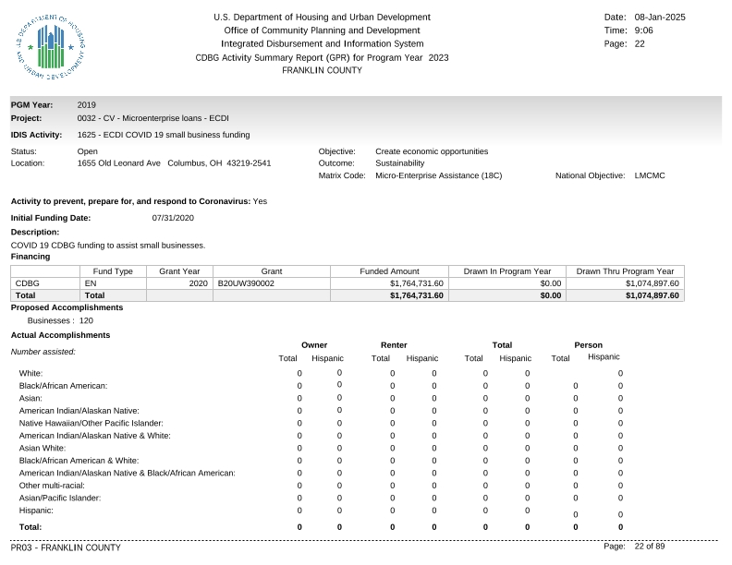
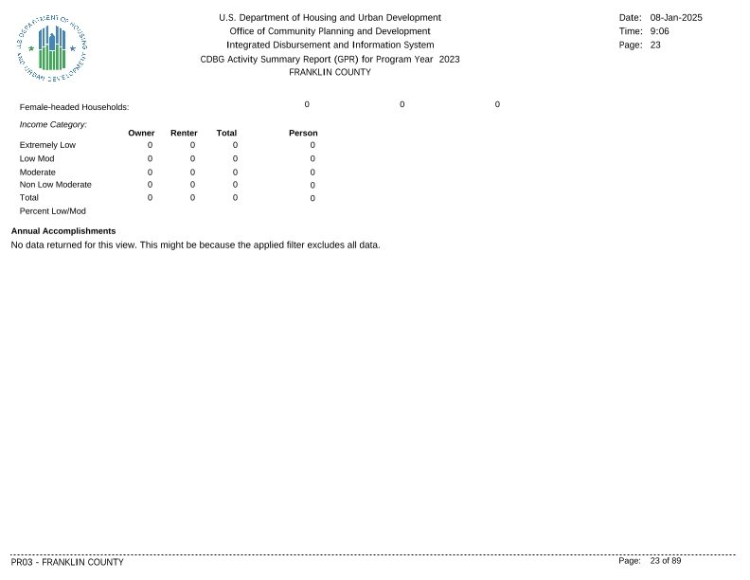
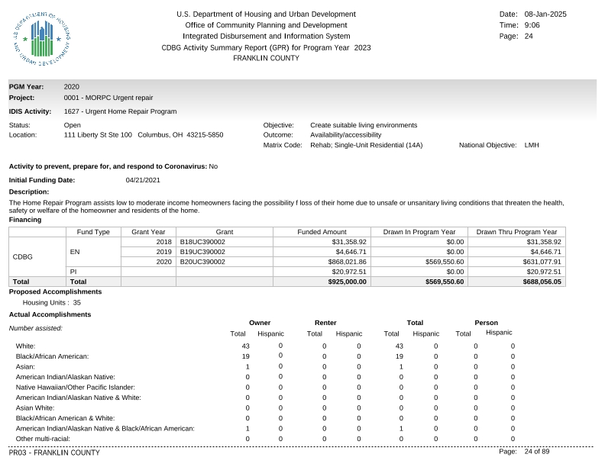
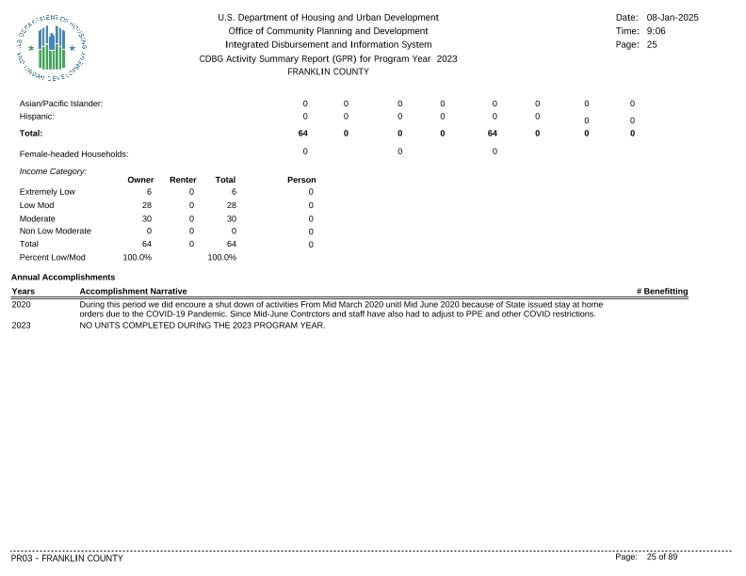
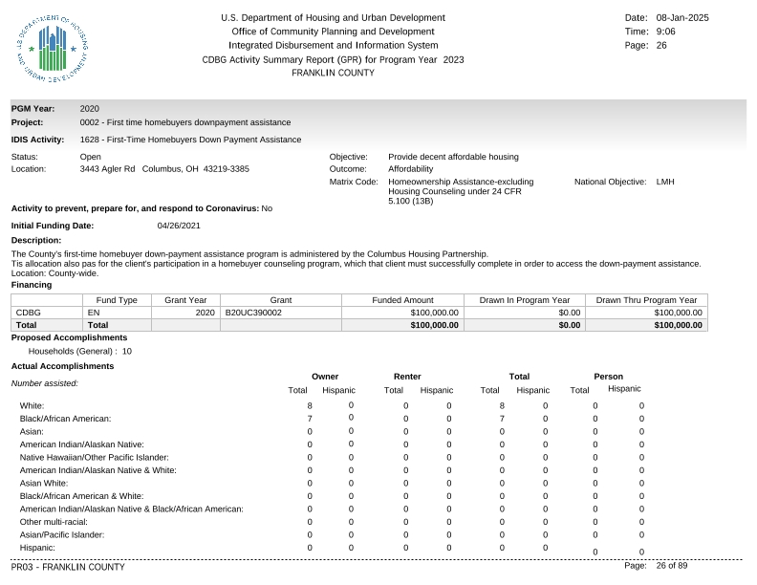
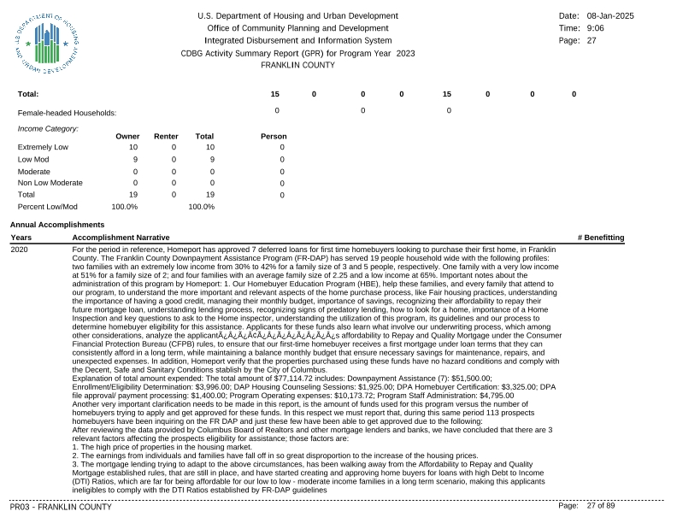
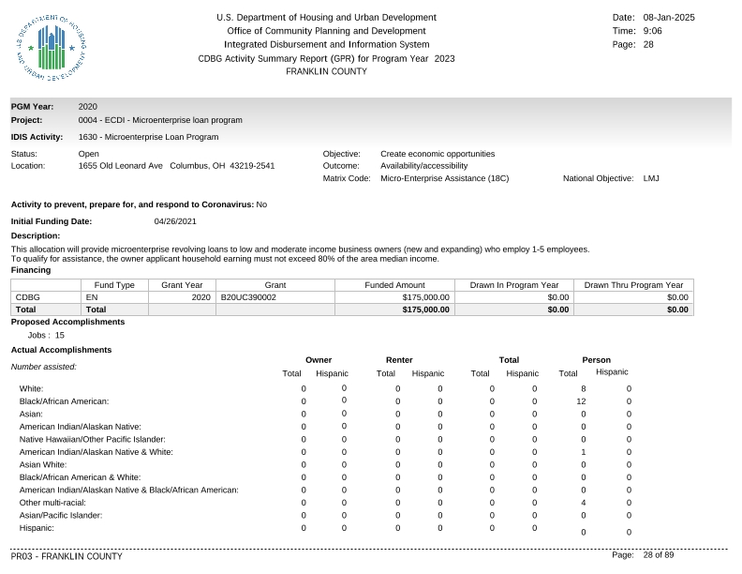
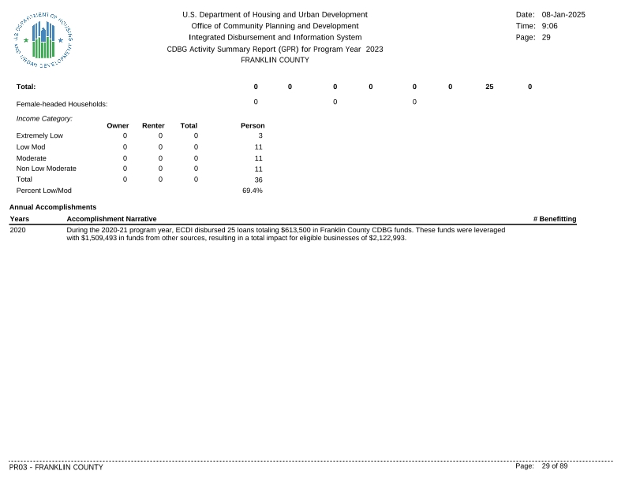
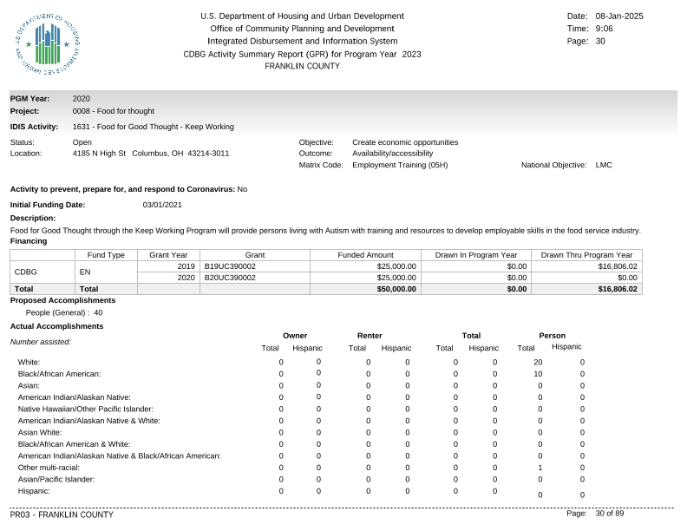
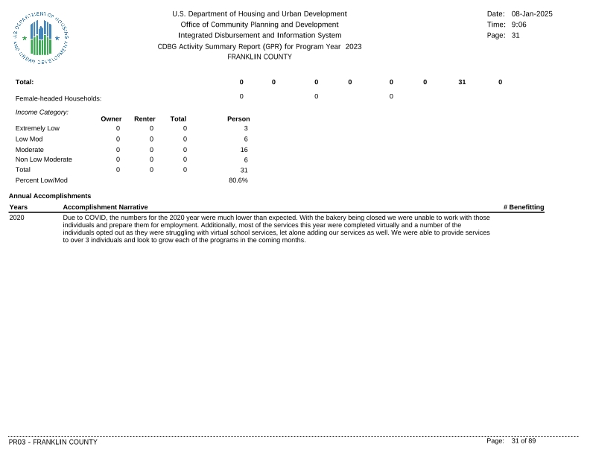
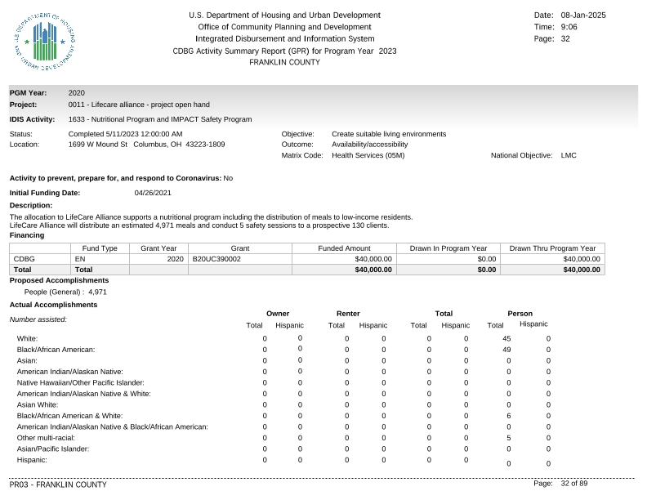
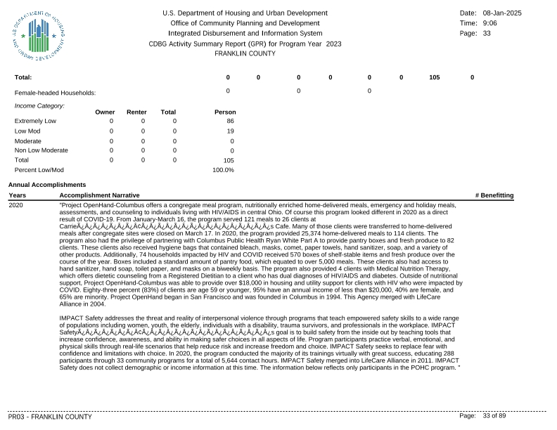
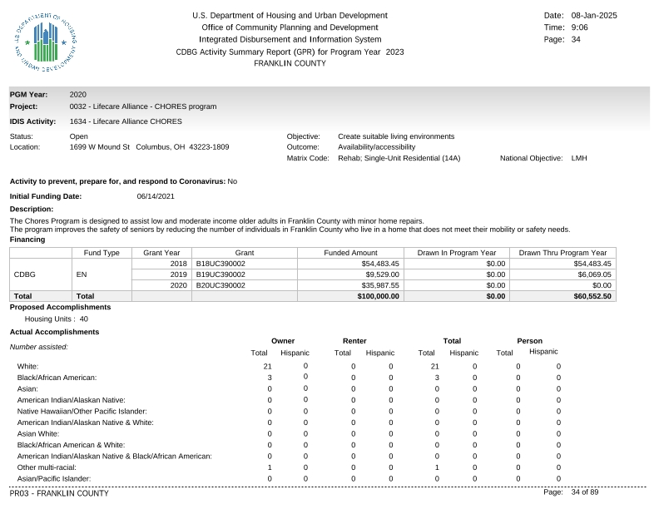
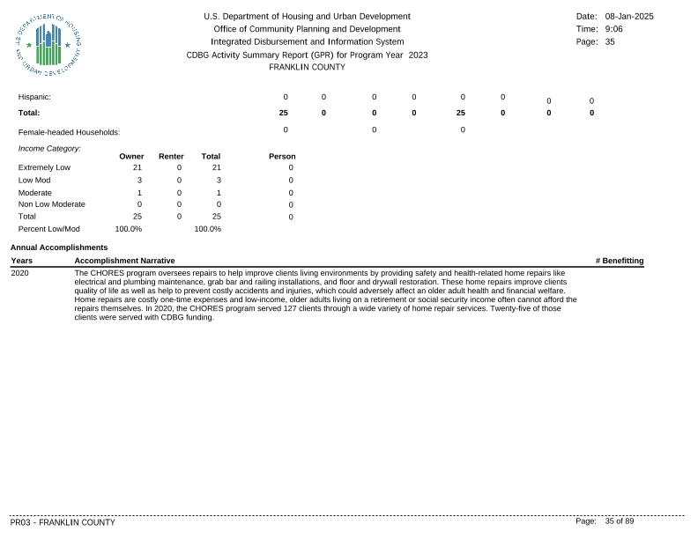
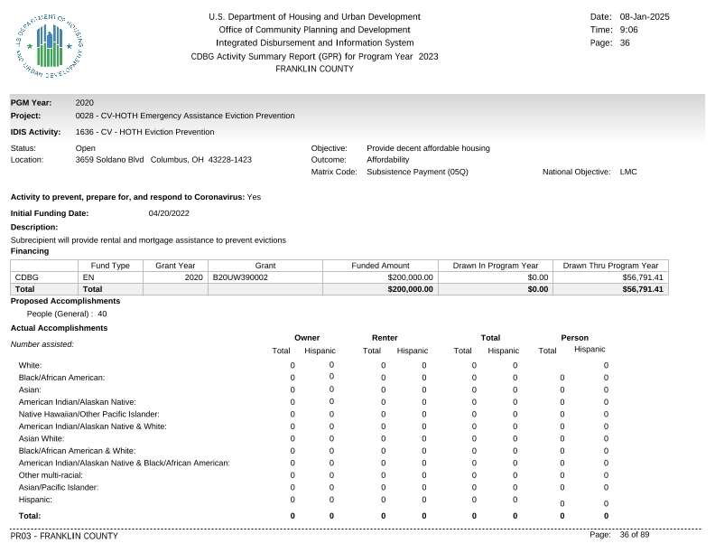
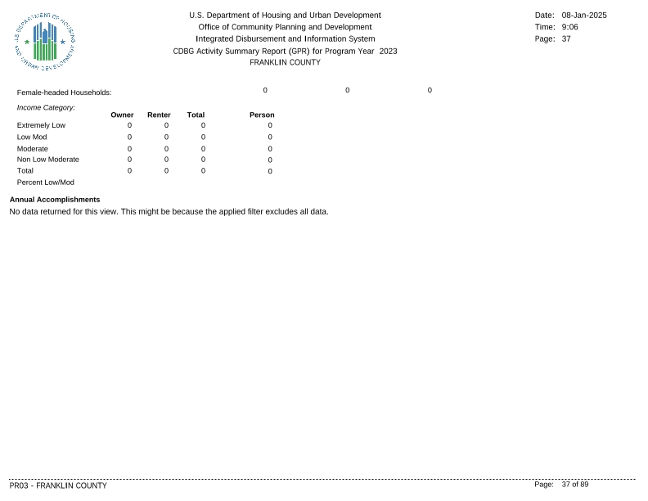
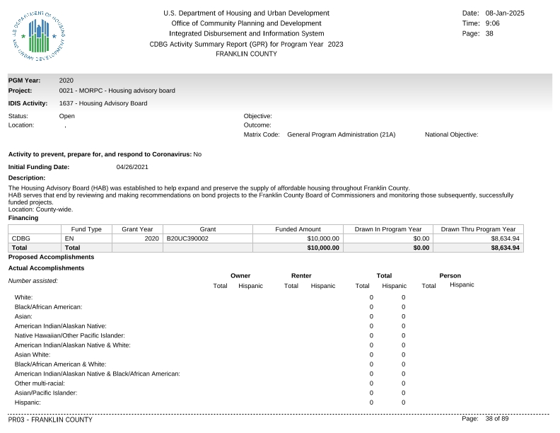
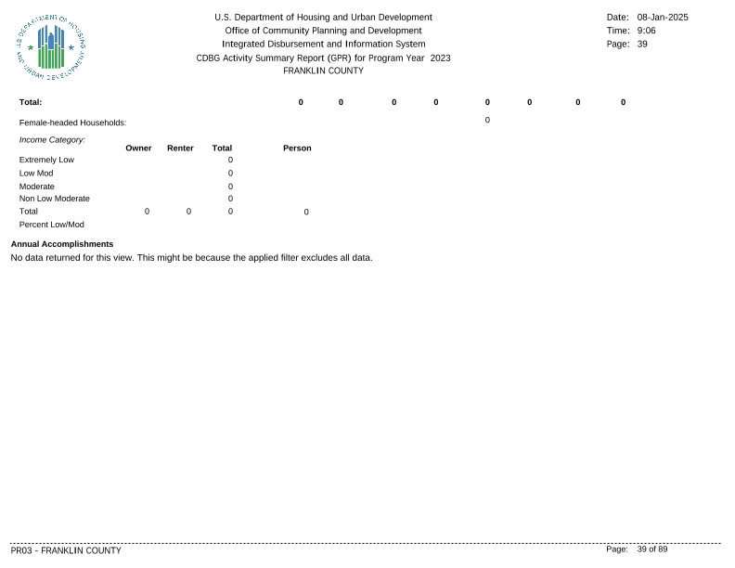
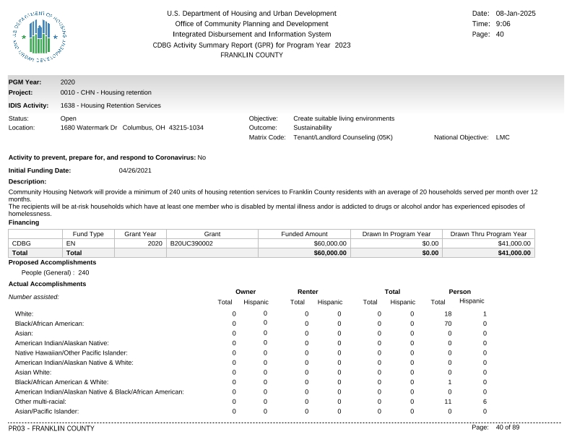
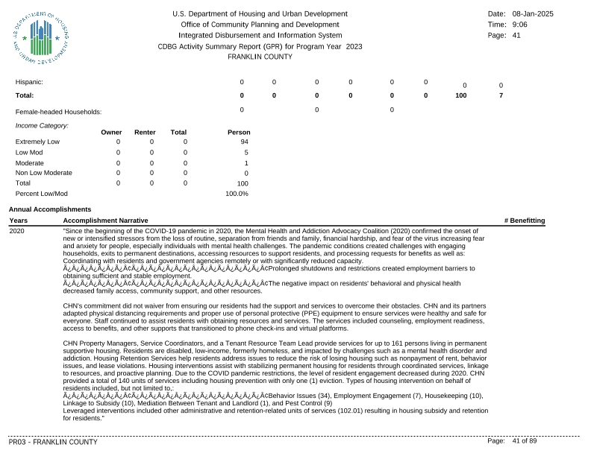
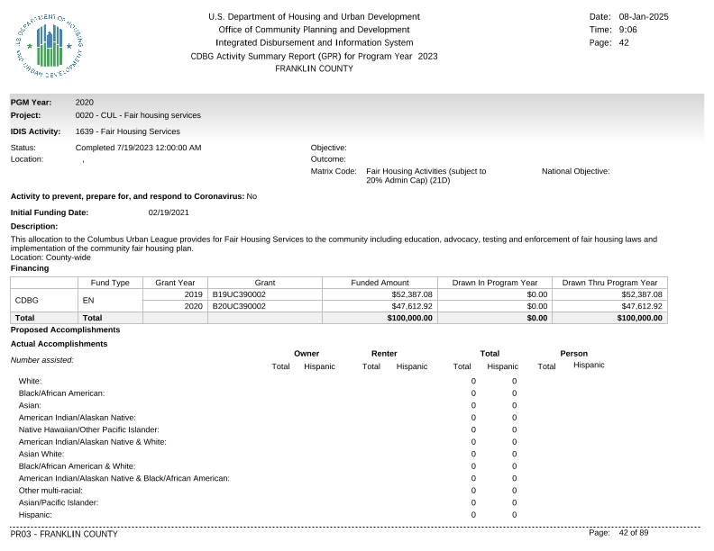
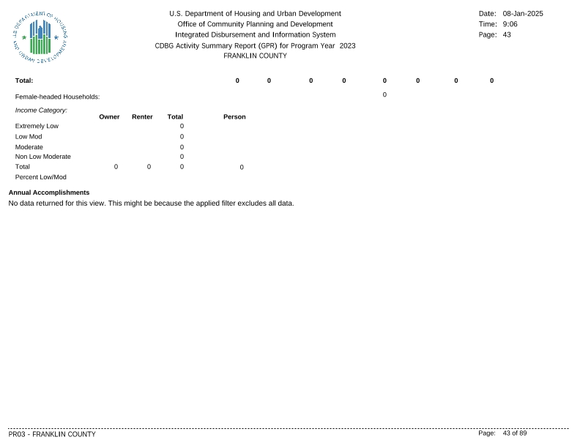
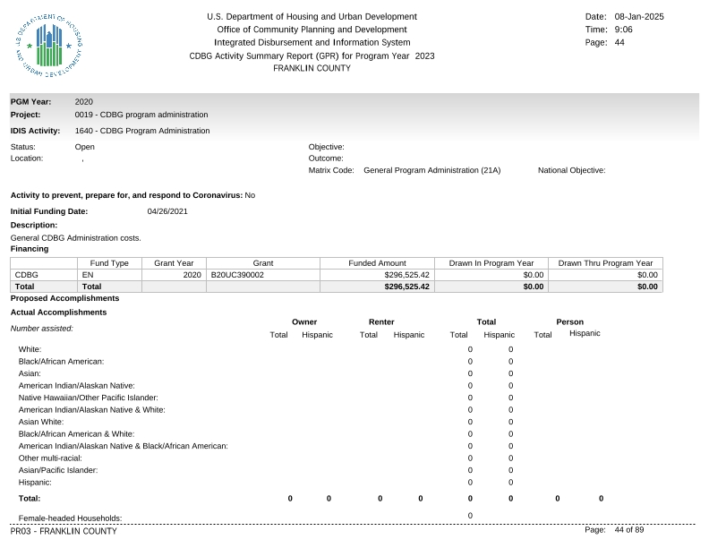
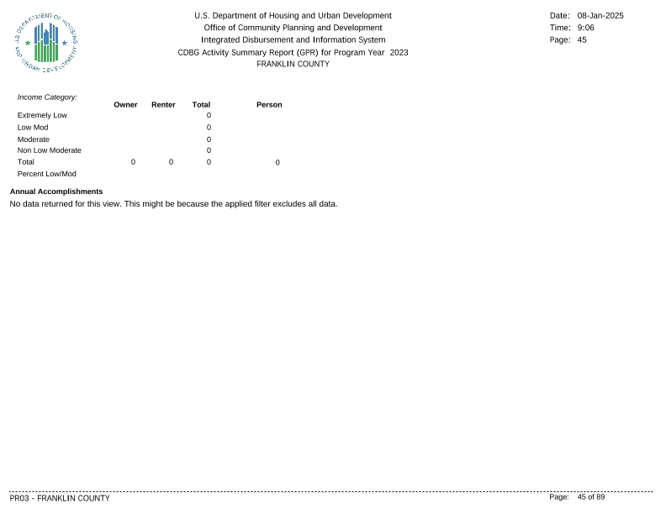
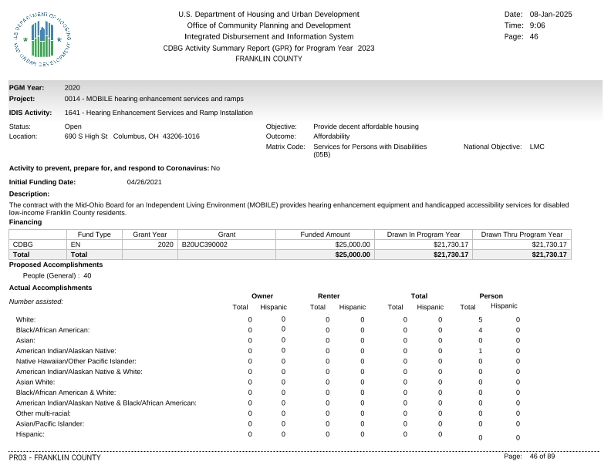
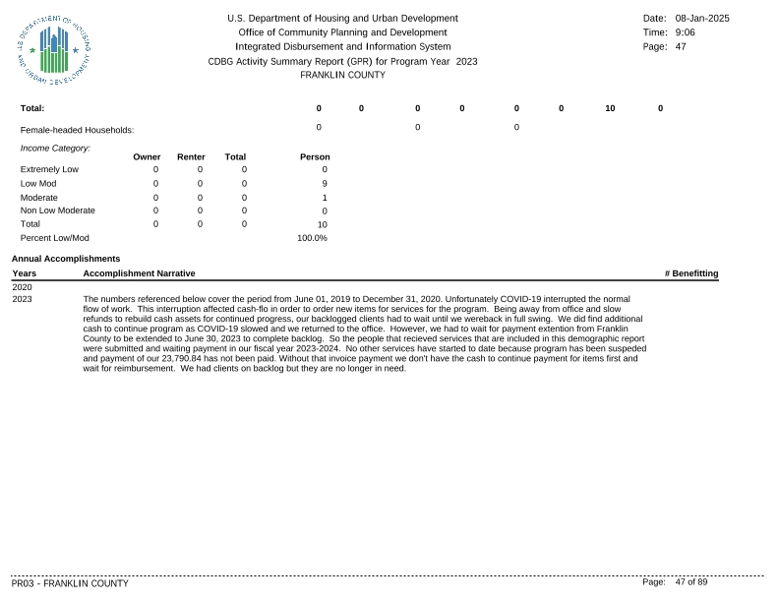
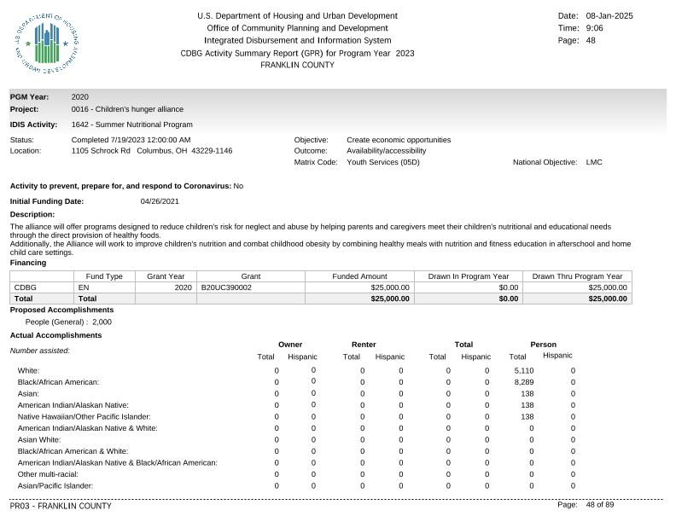
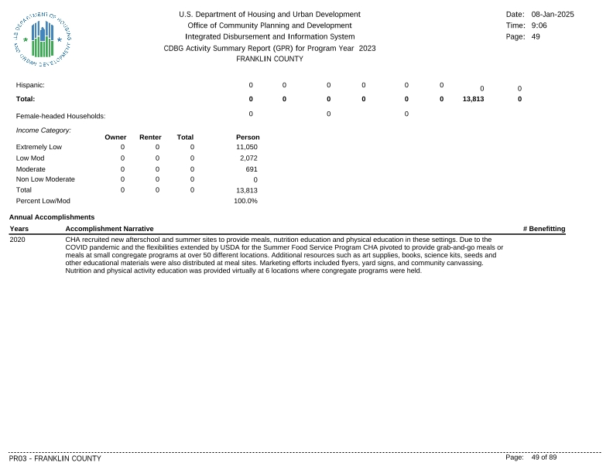
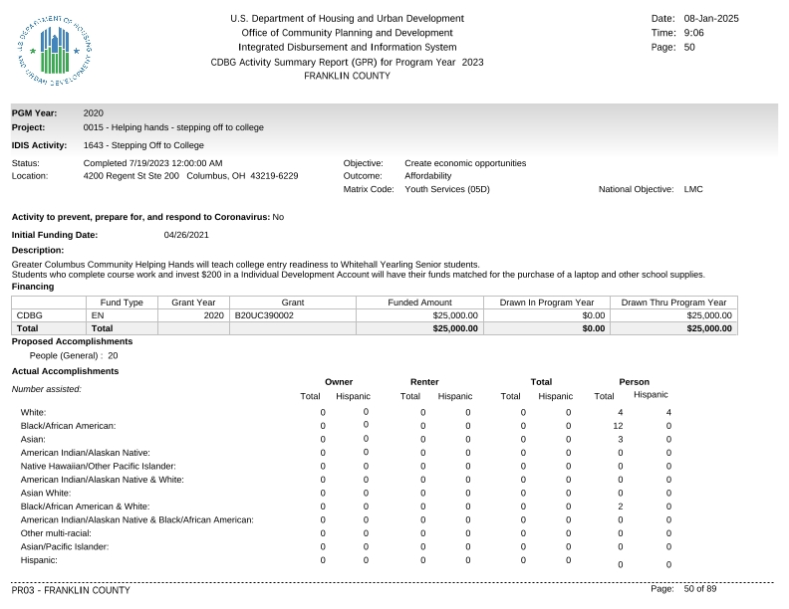
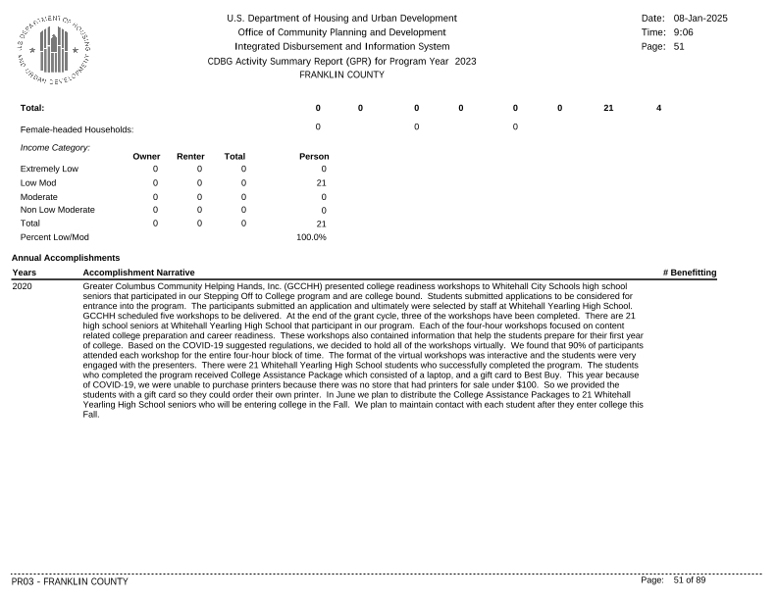
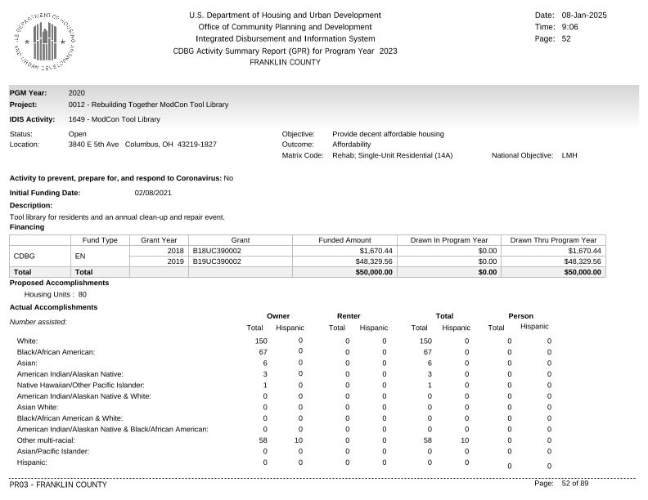
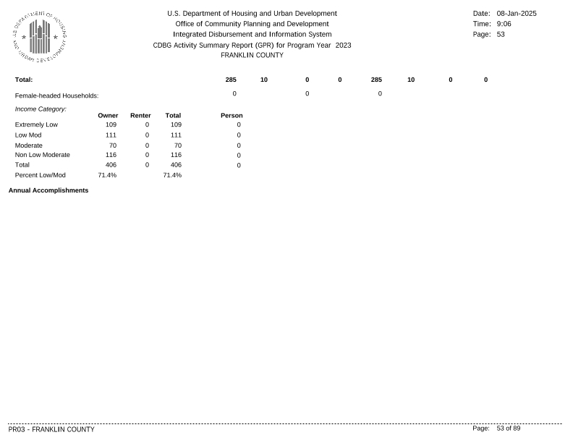
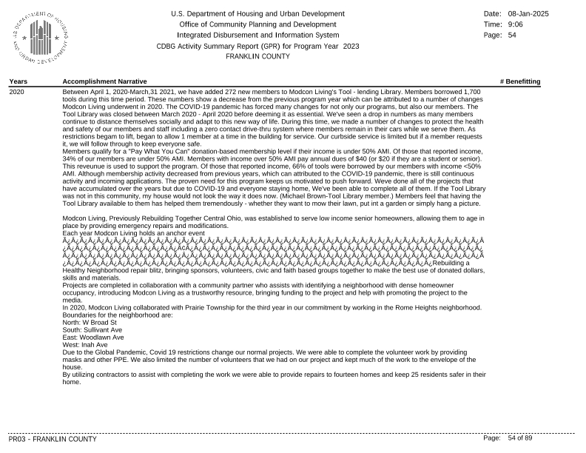
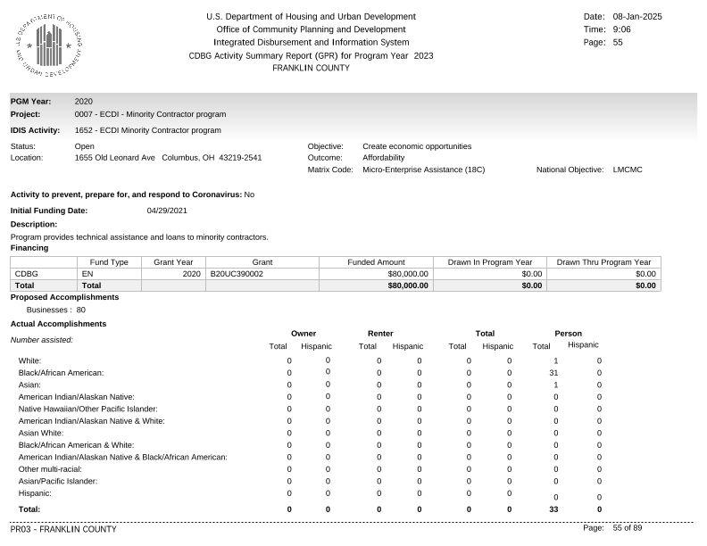
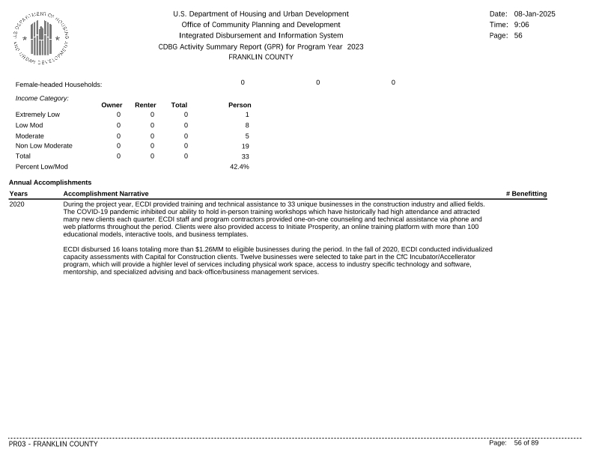
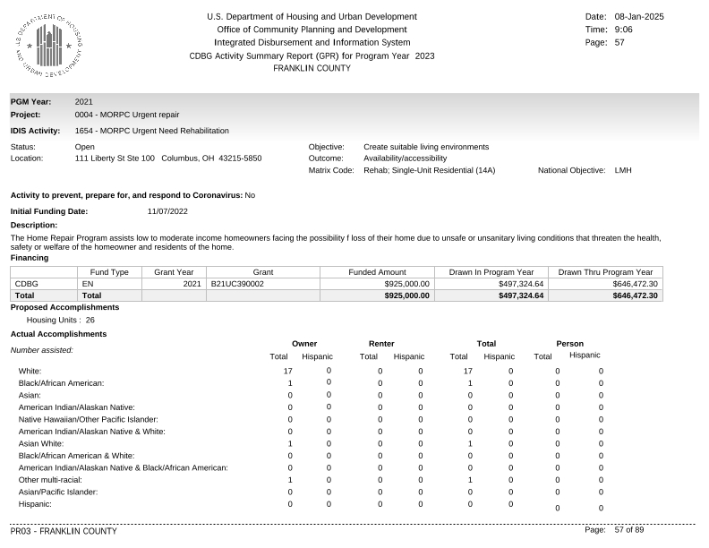
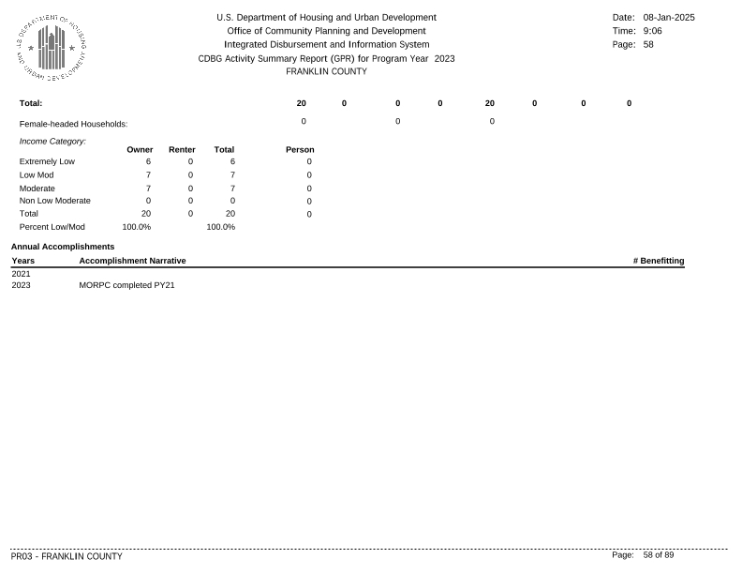
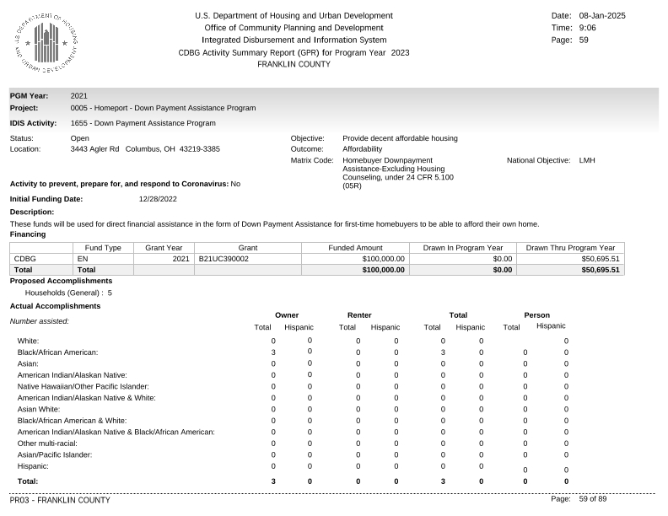
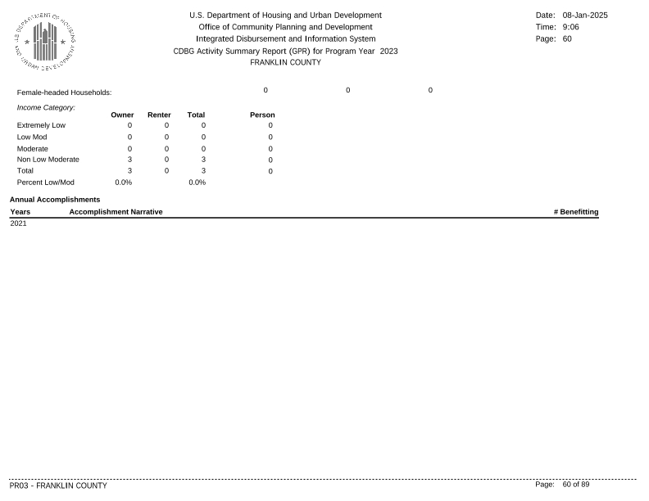
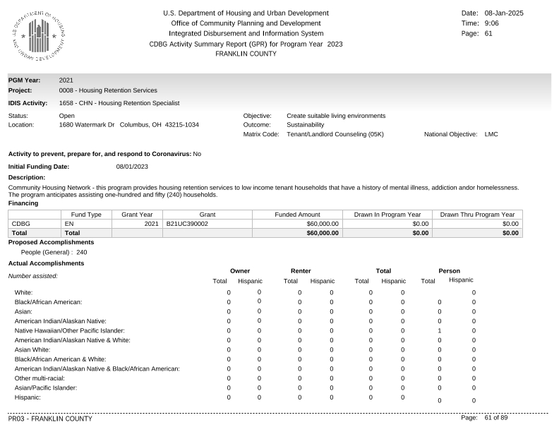
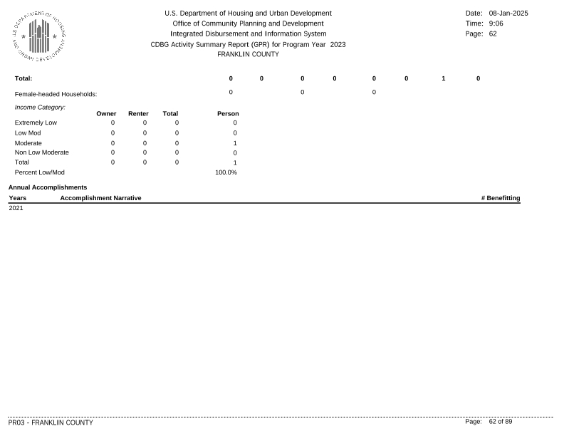
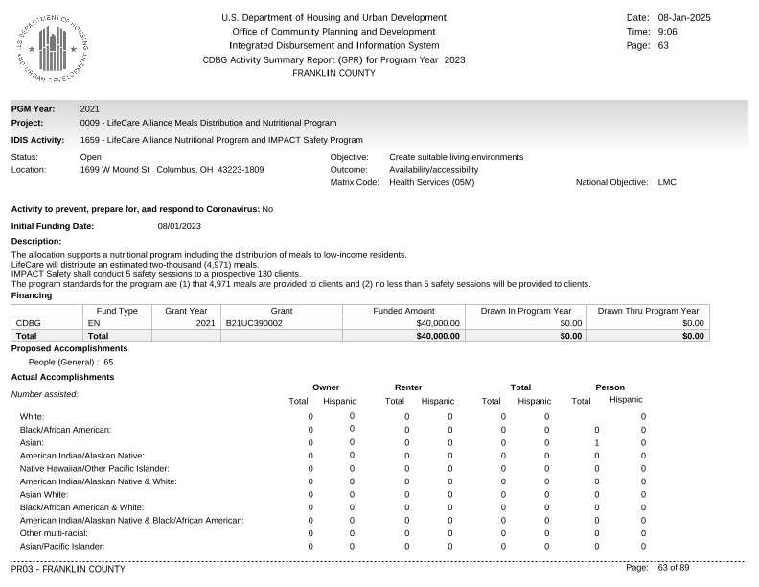
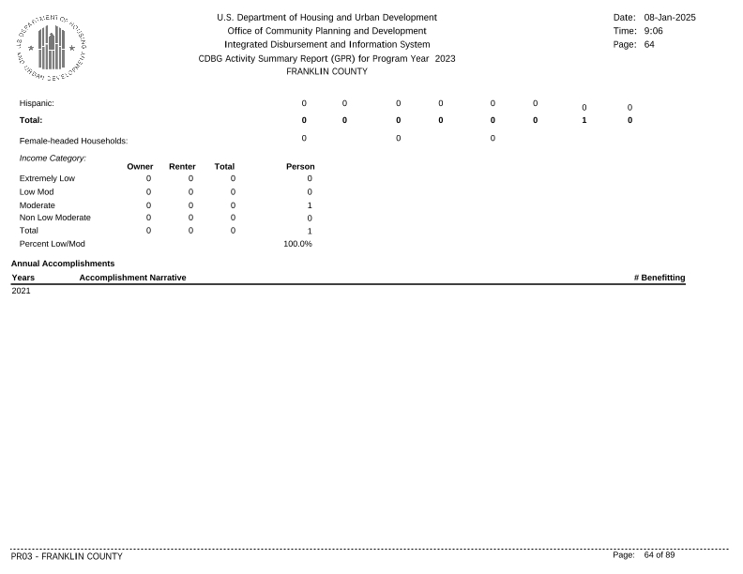
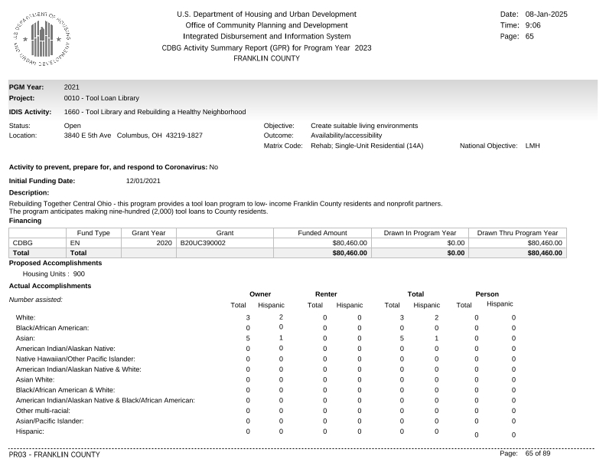
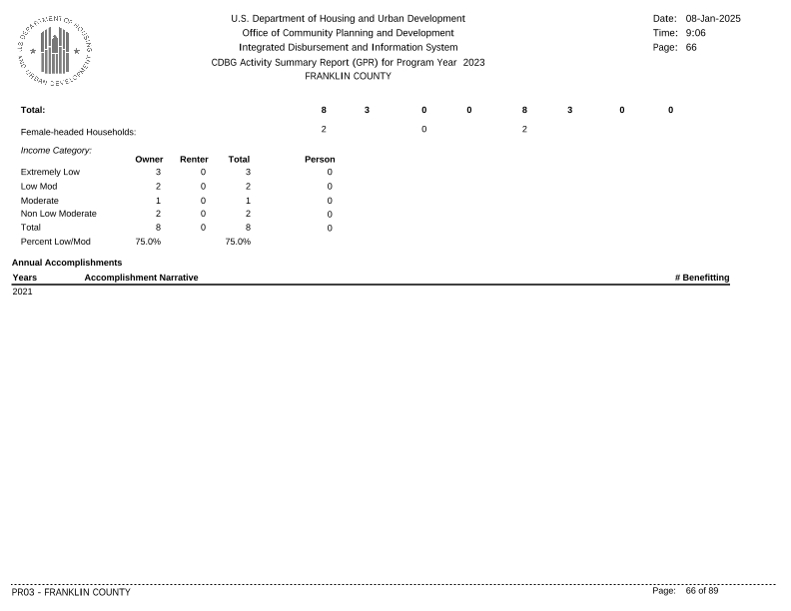
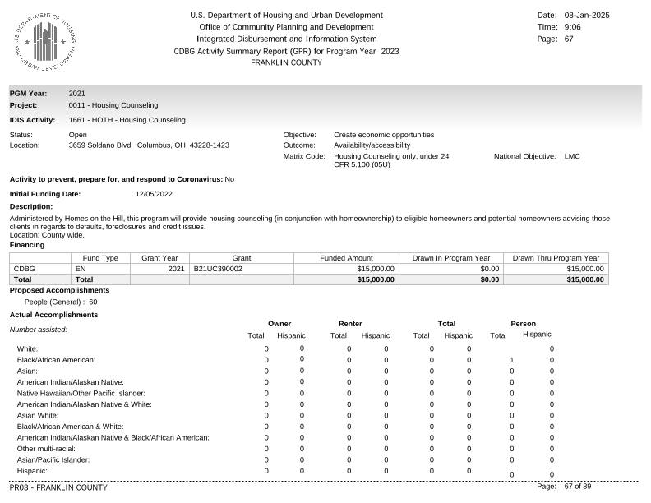
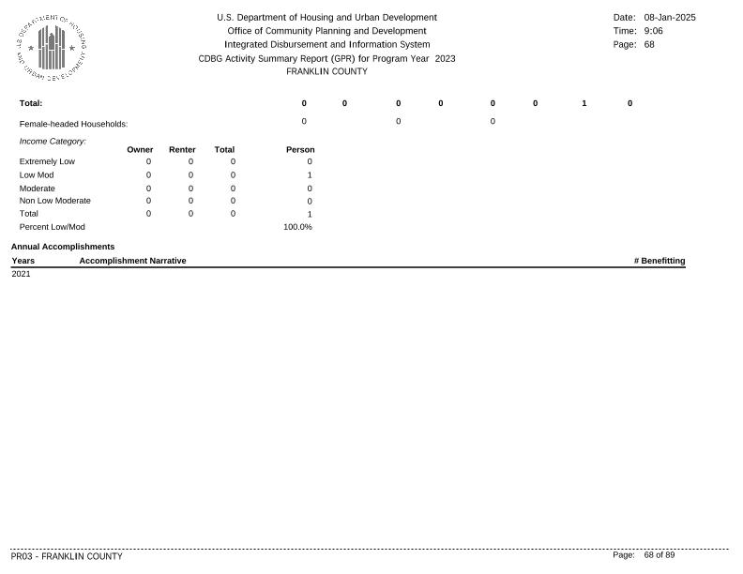
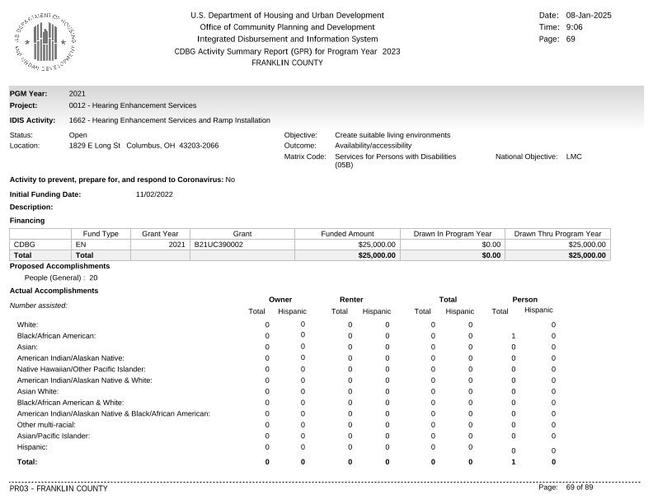
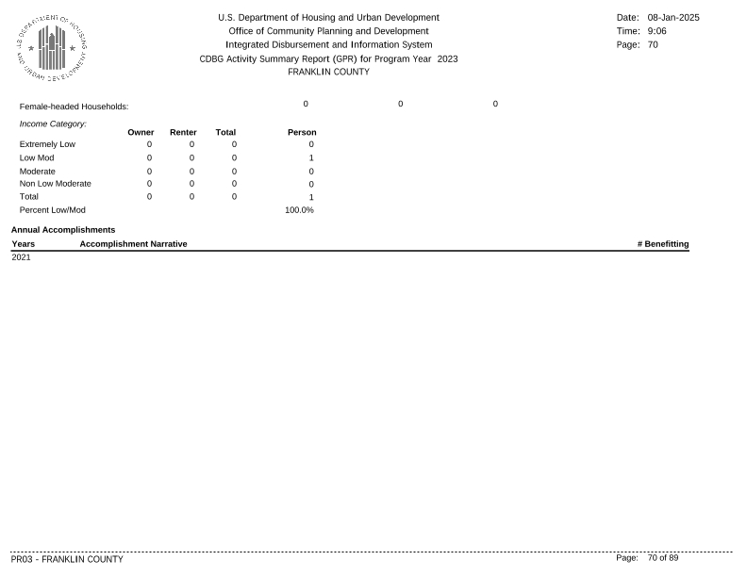
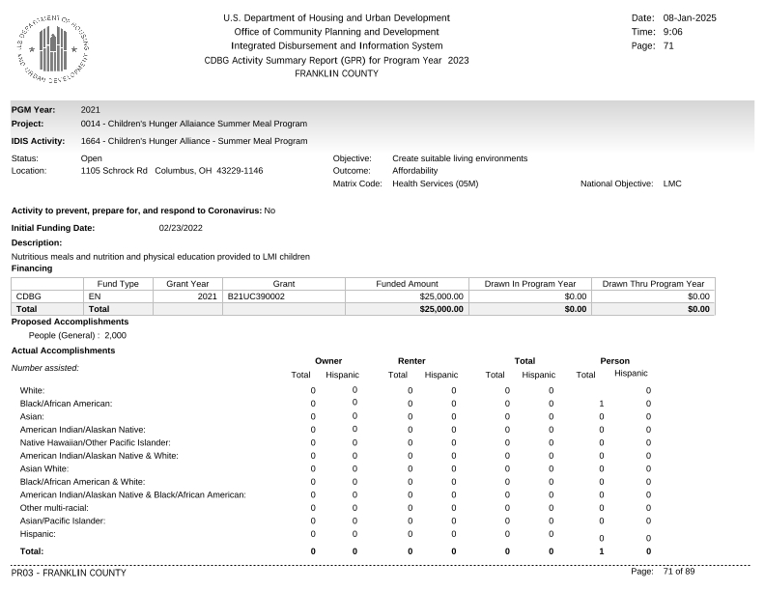
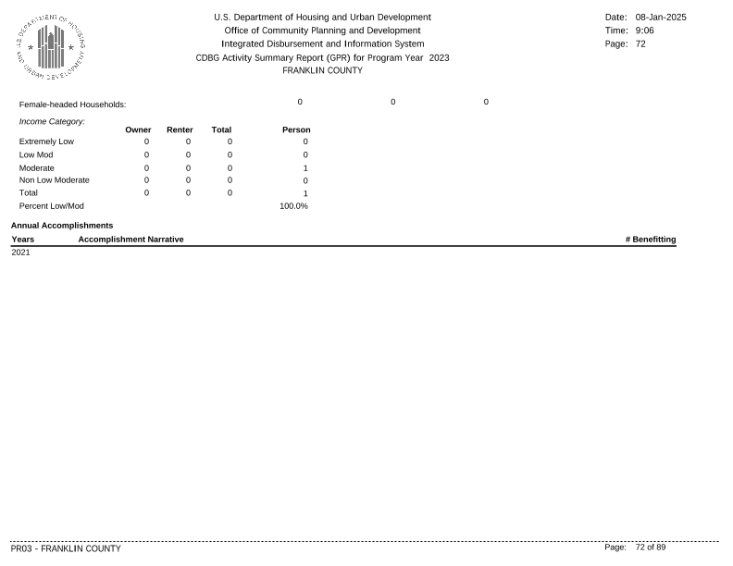
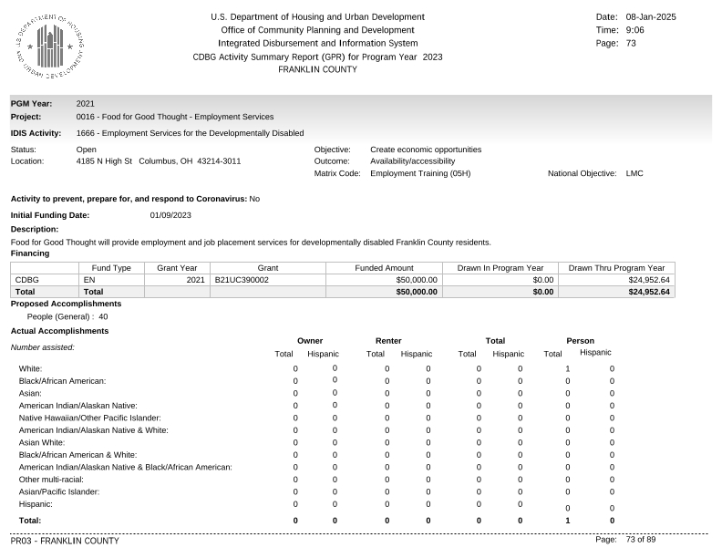
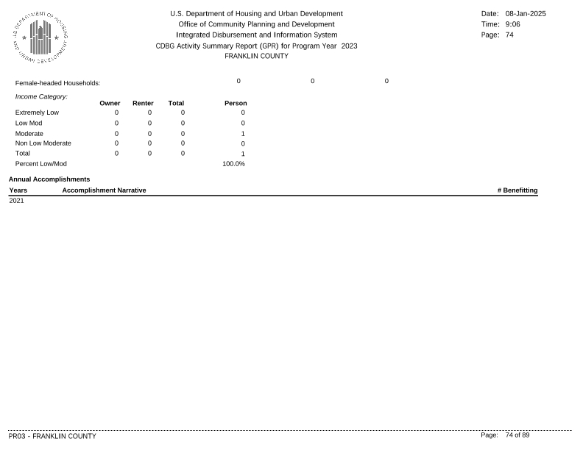
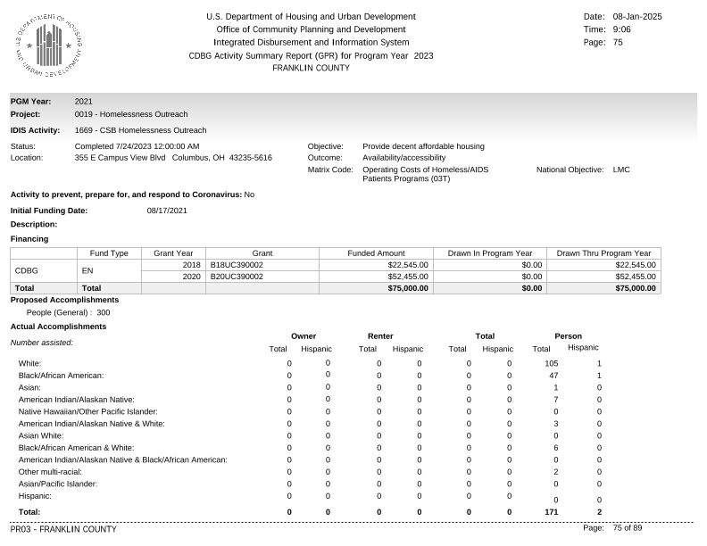
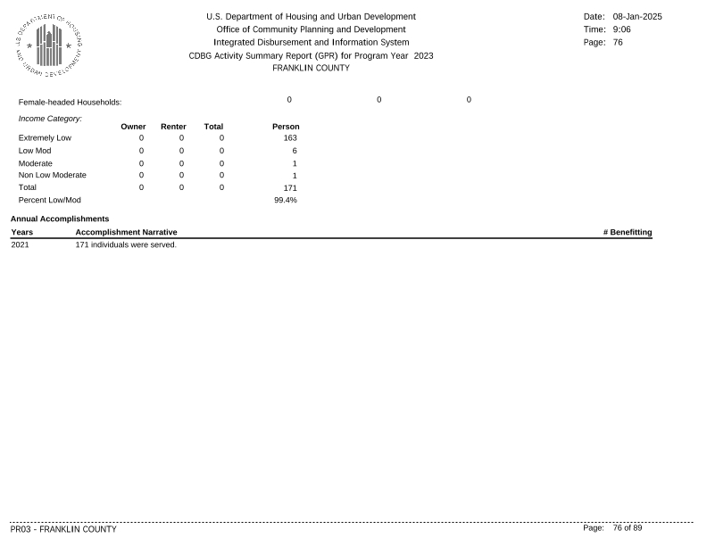
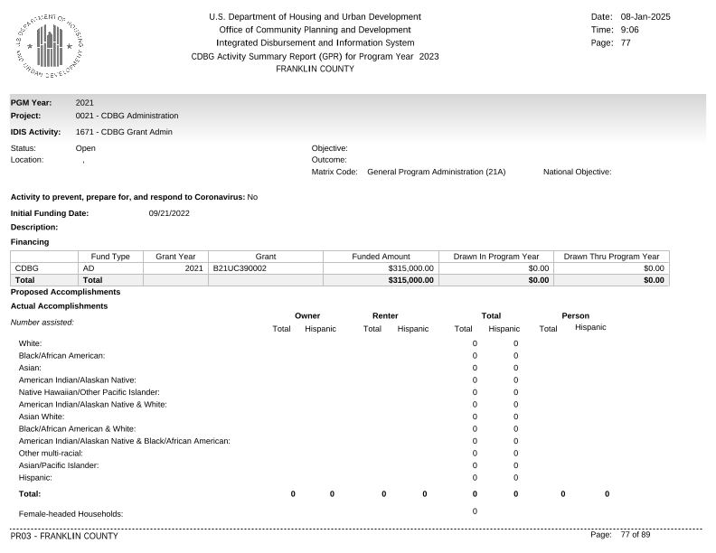
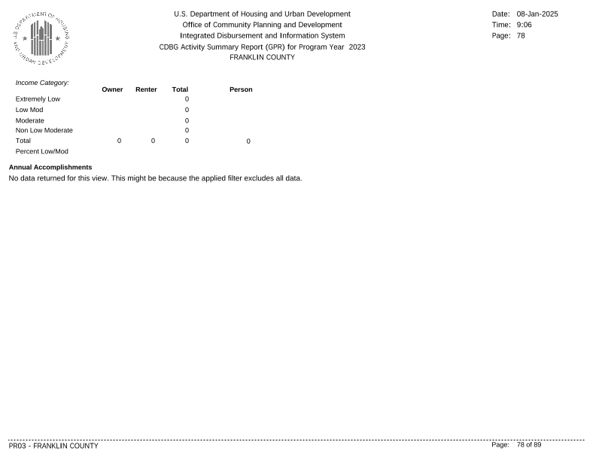
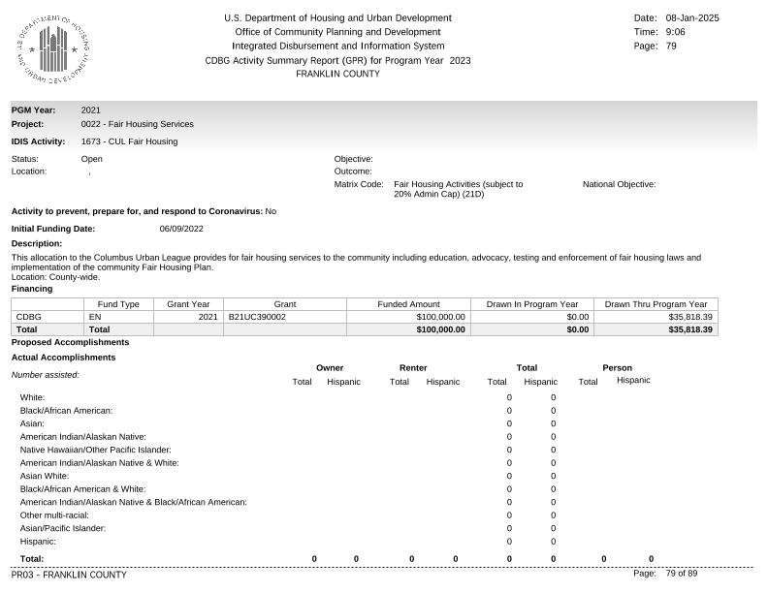
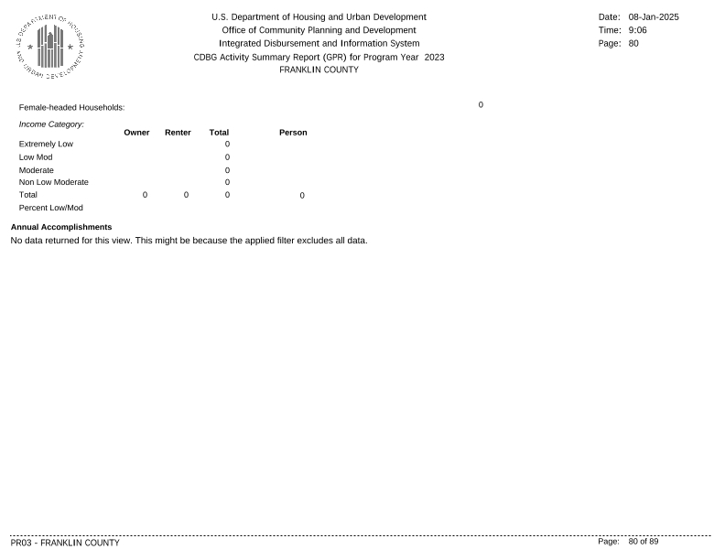
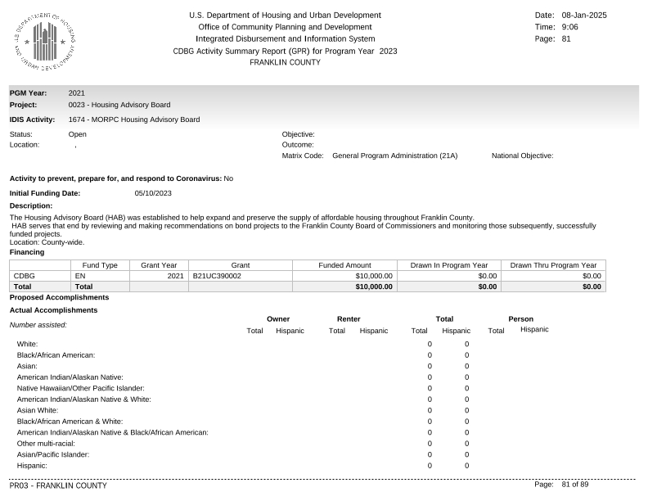
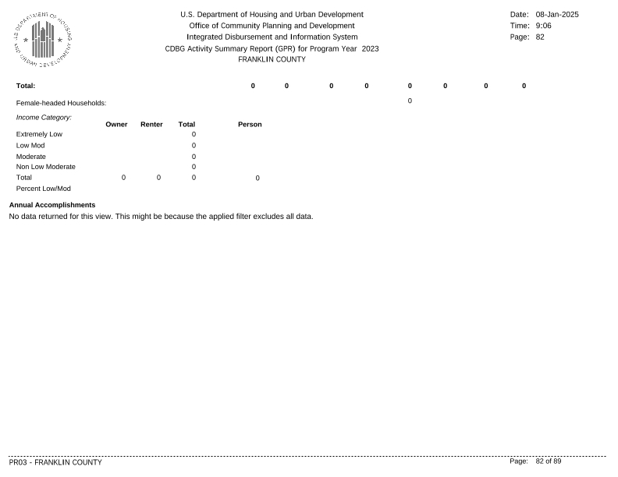
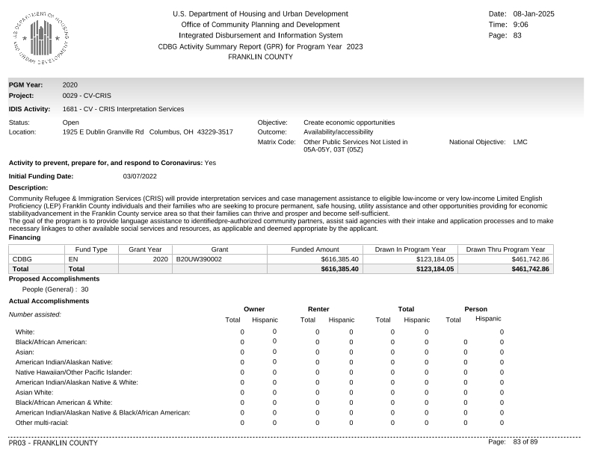
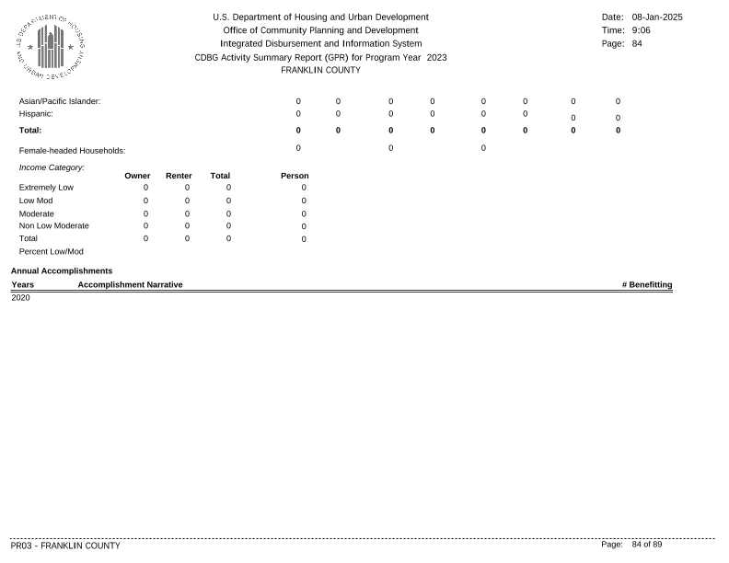
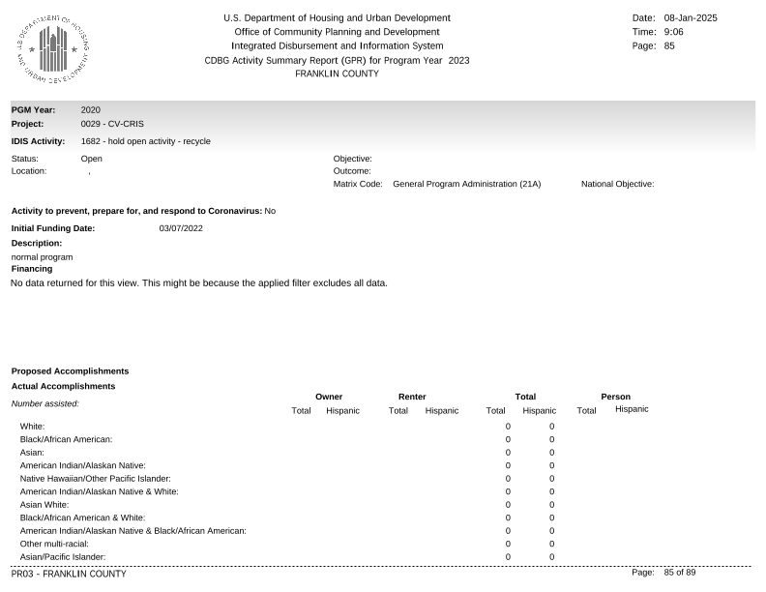
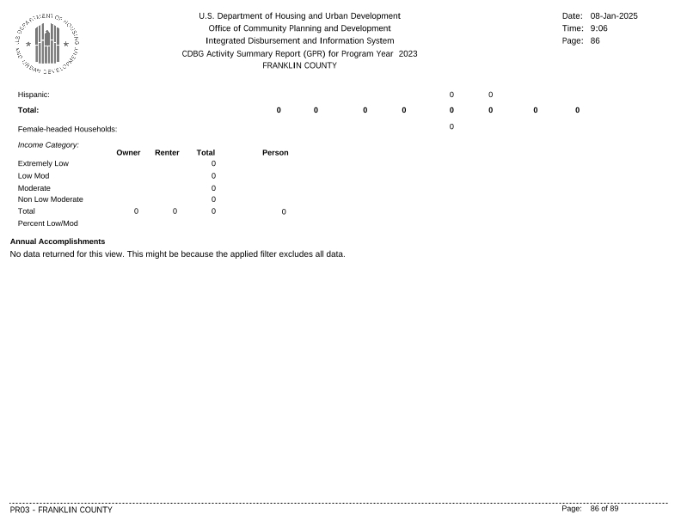
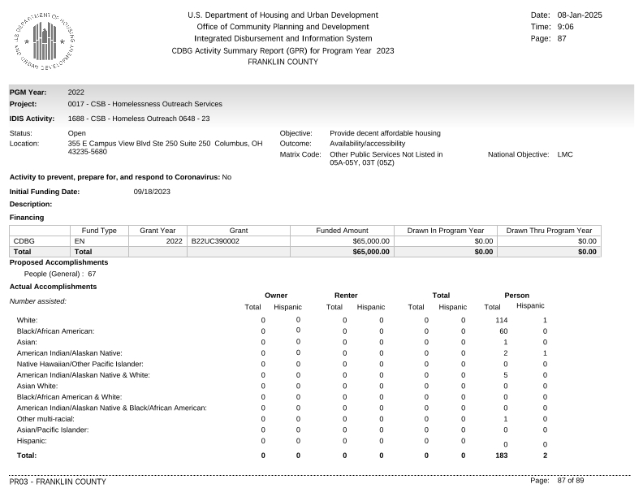
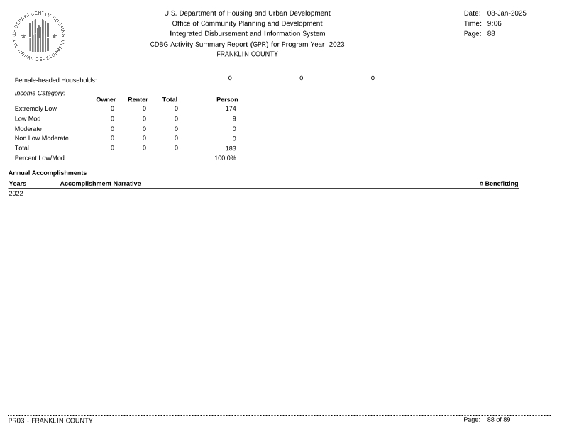
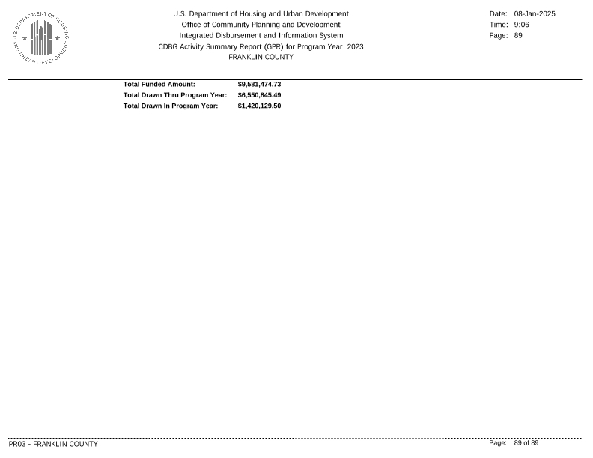

ESG Caper (SAGE)
